

**Blockchain-Enabled Prawn Quality Tracking System**

**Term Paper**

**Course Title:** System Analysis and Design

**Course ID:** CSE307

**Submitted to:**

Sabrina Alam

Lecturer

Department of Computer Science and Engineering

Independent University, Bangladesh

**Submitted by:**

|  |  |  |
| --- | --- | --- |
| **Name** | **Id** | **Section** |
| Md Asif Intesar | 2022430 | 2 |
| Mohammad Azwad Saadat Sarwar | 1910902 | 3 |
| Taiseer Rakiin Ahad | 1911242 | 3 |
| Avijit Saha | 1930109 | 3 |
| Md Yakub Hossain | 1830968 | 3 |

Date of Submission: 02/09/2023

Table of Contents

Section 1: 4

Abstract 4

Introduction 4

History leading to project request 4

Identify Problem, solutions and opportunity 5

Project goal and objectives 6

Section 2: 7

Literature Review 7

References 10

Section 3: 11

Product Description 11

System Context diagram 12

Hardware detail (Include Rich Picture) 12

Rich Picture: 13

Key Technical Features of Software 13

Section 4: 14

Information Gathering methods 14

Story: 14

Interviewing: 16

Questionnaire: 17

Survey Form: 18

Survey Result: 20

Major functionalities offered by the system 25

Use Case Diagram 26

Normal Scenarios 27

14.1 Scenario 1 27

14.2 Scenario 2 28

14.3 Scenario 3 29

14.4 Scenario 4 30

Alternate Scenarios 31

4.1 Scenario 1 31

4.2 Scenario 2 32

4.3 Scenario 3 33

4.4 Scenario 4 34

Functional Requirements 35

Non-Functional Requirements 35

Entity Relationship Diagram 37

Logical Data Flow diagram 38

Physical Data Flow diagram 40

Activity diagrams 41

Sequence diagrams 44

Communication diagrams 46

Class diagrams 47

State-chart diagrams. 48

CRUD matrix 49

Section 6: 50

Structure English pseudo code for the system 50

Prototype the user interface 58

# Section 1:

## Abstract

The “Blockchain-enabled Prawn quality tracking system” addresses the challenges of quality, traceability and transparency in the supply chain of prawns. This paper provides an in-depth look at how blockchain technology can transform the supply chain management of prawns and improve safety and accountability in the food industry. This paper provides a basic overview of the concept, advantages, challenges, and possible future directions of implementation of a blockchain-enabled prawn-quality-tracking system. The blockchain-enabled Prawn-quality tracking system creates an immutable, transparent ledger for the tracking of prawn quality data at various stages of the prawn production, processing and distribution chain. By combining blockchain’s decentralized architecture with smart contracts, this proposed system aims to increase consumer and stakeholder trust, reduce fraud risks, accelerate recalls, and improve the quality assurance process.

## Introduction

Blockchain technology has revolutionized data storage, sharing, and security in many industries. In the food industry, especially the shrimp supply chain, it is essential to ensure quality and traceability. In this paper, we will explore the theoretical basis, potential benefits and practical implications of a blockchain-enabled prawn quality tracking system to revolutionize the prawn industry’s approach to quality assurance & traceability. Like many other industries, the prawn industry is facing challenges in maintaining quality and transparency throughout the prawn’s journey from harvest to consumer’s plate. Consumer trust and safety are at risk due to fraud, mislabeling, and lack of transparency. Blockchain technology, which is decentralized and immutable, has the potential to help address these issues by providing an auditable, tamper-resistant, and transparent ledger for prawn quality data. This will enable stakeholders in the supply chain, such as producers, processors, distributors, and retailers, to collaborate with greater confidence.

## History leading to project request

The decision to implement blockchain technology for the shrimp industry in Bangladesh stems from the concerning decline in shrimp sales and the prevalence of food fraud and lack of authenticity. Despite prawns making up a large portion of Bangladesh's GDP, sales have been falling as a result of consumer mistrust and worries about the items' provenance and quality. The fishing supply chain's current systems and technology have shown to be insufficient for solving the crucial issues of traceability, dependability, trust, privacy, and security. Consumer confidence has been eroded as a result of traditional record-keeping and paper-based tracking systems that left potential for corruption and data tampering.

Here are some bullet points that explain the history behind the need for a "Blockchain-enabled prawn quality tracking system":

1. **Supply Chain Complexity:** The global shrimp industry has grown exponentially, resulting in complex supply chains that involve fishermen, processors and distributors, as well as retailers. This complexity has often led to challenges in terms of quality control and traceability, as well as in terms of consumer trust.
2. **Quality Assurance Issues:** In recent years, there have been a number of mislabeling, contamination and fraud in the shrimp supply chain. These incidents have highlighted the need for stronger tracking mechanisms to guarantee product integrity and traceability.
3. **Regulatory Pressure:** In the food industry, there is a growing focus on traceability, transparency, and quality. The shrimp industry has been under increasing pressure to meet these demands, and stakeholders are looking for innovative solutions.
4. **Consumer Demand for Transparency:** Today’s consumers are more discerning than ever before. They want to know where their food comes from, they want transparency in their supply chain, and they want accurate information about what they’re buying. As a result, the shrimp industry has been forced to embrace new technologies in order to meet these demands.

## Identify Problem, solutions and opportunity

|  |  |
| --- | --- |
| **Problem** | **Solution** |
| **Food Fraud and Adulteration:** The prawn sector in Bangladesh suffers from food adulteration and fraud, which damages consumer confidence and reduces sales. To increase their profits, many farmers may mislabel, combine, or substitute prawn products, so jeopardizing their originality and quality. | **Blockchain-based Traceability:** Shrimp traceability issues will be resolved by implementing a blockchain-based database. From the time the prawn is captured until it is delivered to the store, every step of its journey will be immutably recorded on the blockchain. As a result, stakeholders will be able to confirm the legitimacy and provenance of the prawns at any stage of the supply chain. |
| **Lack of Traceability:** It is challenging to trace the origin, handling, and processing of prawns due to the traditional supply chain systems' lack of thorough traceability. The inability to clearly identify the origins of contamination or negligence makes it difficult to ensure the safety of food. | **Smart Sensors and IoT Integration:** Smart sensors and Internet of Things (IoT) devices can be installed at various points throughout the shrimp's route to improve data collection. The blockchain will be used to store the relevant data that these sensors will automatically collect, such as temperature, location, and handling circumstances. All parties concerned will have access to correct and current information thanks to this connection. |
| **Inefficient Supply Chain:** The existing supply chain operations are inefficient and sluggish as a result of paper-based procedures and manual record-keeping. Decision-making and resource allocation are less than ideal as a result of the lack of real-time data exchange and openness. | **Decentralized Data Access:** The decentralized nature of blockchain will give a variety of parties, such as customers, suppliers, processors, and regulators, secure access to the data they require. By fostering trust and collaboration among participants, this transparency will improve supply chain management. |

**Opportunities:**

* **Enhanced Consumer Trust:** The blockchain-based approach will boost consumer trust in the sector by giving consumers comprehensive and verifiable information on the prawns they buy. This increased trust may result in greater consumer demand for genuine prawn goods, which would help the market expand. Once this is put into practice, all prawn farmers will be required to utilize this type of authenticity in order to remain in business because if they don't, customers will know they might not be supplying the best products.
* **Sustainable Fishing Practices:** The blockchain will make it easier to track fishing techniques, supporting eco-friendly and sustainable practices. This will open doors for the prawn sector to access premium markets that value ecologically friendly products and accord with global sustainability standards.
* **Data-Driven Decision-making:** The blockchain's accessibility to historical and real-time data will enable stakeholders to take data-driven decisions. While authorities can more effectively enforce adherence to fishing restrictions, producers can optimize their processes based on consumer preferences.
* **Export Market Expansion:** The prawn business in Bangladesh might gain a competitive edge on the international market with improved traceability and transparency. International customers might favor prawn items from a blockchain-enabled supply chain, especially those who are worried about food safety and authenticity.

## Project goal and objectives

The aim of this initiative is to improve the clarity, trackability, and legitimacy of shrimp products within Bangladesh's fishing supply chain through the integration of a database built on blockchain technology. The specific objectives of the project are as follows:

* **Reduce Corruption and Adulteration:** The prawn industry's corruption and adulteration are the main targets of this initiative. The technology will prevent fraudulent actions and guarantee the accuracy of product information by documenting the whole route of prawns from its source to the shop on a safe and unchangeable blockchain.
* **Improve Food Safety and Consumer Health:** Ensuring the shrimp's traceability across the supply chain will allow for the quick detection of any potential fraud or contamination. Consumers can feel more confident in the security and caliber of the prawns they buy by reducing food fraud and ensuring product authenticity.

* **Enhance Supply Chain Efficiency:** By providing real-time data at each level of the process, the implementation of blockchain technology will simplify the prawn supply chain. Increased transparency will result in more effective decision-making, fewer delays, and overall supply chain operations that are optimized.
* **Establish Consumer Trust:** Consumers will have more faith in the prawn industry if it provides complete openness and easy access to information about the prawns they purchase. They can confirm the shrimp's origin, handling, and processing specifics, building a tighter bond between producers and consumers and boosting sales.
* **Foster Sustainable Fishing Practices:** By enabling the tracking of the shrimp's origin, fishing techniques, and adherence to pertinent legislation, the blockchain system will encourage sustainable fishing methods. By identifying and addressing unsustainable fishing practices, this information can support environmental conservation.

# Section 2:

## Literature Review

In the ever-evolving landscape of the modern food industry, ensuring quality, traceability, and transparency in the supply chain is paramount. This is especially true for our startup's mission to revolutionize the prawn industry with the "Blockchain-enabled Prawn Quality Tracking System." As the prawn industry faces challenges of mislabeling, fraud, and consumer trust erosion, the need for innovative solutions becomes increasingly apparent. In this context, conducting a comprehensive literature review to explore the existing research landscape on blockchain-enabled supply chain systems becomes an essential undertaking [1] [2].

The purpose of this literature review is to delve into the existing body of knowledge surrounding blockchain technology's application within supply chain management, particularly in the prawn industry. By synthesizing and analyzing the research and insights gathered from various sources, we aim to understand the strengths and limitations of blockchain-based solutions in enhancing quality assurance, traceability, and transparency. This review serves as a crucial foundation for our paper, which outlines the potential of our "Blockchain-enabled Prawn Quality Tracking System" and its alignment with addressing the prawn industry's pressing concerns.

In the following sections, we will navigate through the key findings of relevant studies, explore the various applications of blockchain in supply chain management, and discern how these insights resonate with our startup's objectives. Ultimately, this literature review will not only contextualize our startup's innovative solution but also contribute to the broader discourse on leveraging blockchain technology to ensure food safety, build consumer trust, and drive positive transformations in the prawn industry.

The preferred reporting items for systematic reviews and meta-analyses (PRISMA) model was used to perform a systematic review of the literature for this investigation [3]. The PRISMA model involves a number of steps for the compilation and review of the literature. In order to find the existing literature on fish adulteration/contamination in Bangladesh, we looked at the following online sources: Google Scholar, Web of Science, Scopus, and Science Direct.

**Blockchain Technology in Supply Chains:** The study explores the application of blockchain technology to tackle challenges in the fisheries sector, including fraudulent supply chains, overfishing, and quality issues. Blockchain is an approach to digitizing data and sharing information across a multi-layered supply chain network securely and reliably. The integration of blockchain into shrimp supply chains could enhance the quality of product information for compliance and sharing with consumers. It could provide additional traceability from the farm to the transportation stage, monitoring food safety practices throughout the development and processing of shrimp. Blockchain could add a layer of visibility to shrimp products, providing additional peace of mind for overseas customers and reinforcing India's reputation as a trusted seafood source. The potential to revolutionize the seafood community lies in blockchain technology, and organizations must take the initiative to test its capabilities to improve supply chain processes, as one of the world's most traded commodities with a complex and multi-layered global supply chain. Testing and further development of technology-supported traceability programs is an essential next step [4]. One of blockchain’s key advantages is its ability to authenticate products. By recording every step of the supply chain securely, blockchain can verify the origin of products, giving consumers peace of mind that the items they buy are real [5].

**Shrimp Supply Chain Quality Tracking:** Blockchain in combination with IoT can help prevent product mislabeling, whether intentionally or inadvertently. Blockchain records transactions when a product changes location or passes through a process step. IoT can capture this movement automatically via RFID (Radio Frequency Identification) tags or built-in sensors that talk wirelessly. Reducing food fraud may be one result of implementing this technology duo. The combination of blockchain and IoT allows for the detection of lower-quality products that are falsely labeled as premium, says Braathe [6]. There is still much work to be done in terms of freshness monitoring. For example, given the international nature of supply chains, governance standards for blockchain data exchange must be harmonized at an international level, which is something that IBM and others are working on. In the IBM case, the uploader retains control over the data and decides who can view it [7].

Blockchain’s transparent and decentralized ledger records every step of the supply chain in an immutable way. This transparency is extremely important when tracking the movement and processing of food products. For example, Walmart’s blockchain project showed how transparency could be achieved by tracking shrimp export from farmers to retailers [4]. Blockchain’s distributed nature means that data is always up-to-date and available to authorized parties. This efficient data management reduces fragmentation and facilitates real-time information exchange [1] . Blockchain solutions are solving the problems of traditional supply chains by improving transparency, streamlining data management, and automating processes to ensure food safety and quality.

**Prawn Industry and Quality Assurance:** The importance of quality tracking in food supply chains cannot be overstated, as it has a direct effect on consumer health and well-being. Research consistently emphasizes the importance of maintaining product quality across the entire supply chain. Food safety traceability systems have a key role in protecting public health and safeguarding food product integrity [8]. Not only does quality tracking help identify the source of contamination, but it also reduces the risk of unsafe products being distributed.Blockchain technology provides traceability throughout the entire prawn production chain. Every step of the prawn production chain, from harvesting, to processing, to distribution, is traceable and verifiable. The traceability of prawn production ensures traceability of the origin and path of the prawn products, which reduces the risk of fake prawn products [5].

Integration of IoT devices and sensors into the shrimp supply chain can enable real-time monitoring of environmental conditions, including temperature and humidity. This means immediate action can be taken if conditions pose a risk to product quality and reduce spoilage. Technology-enabled solutions not only enhance the quality of shrimp products but also increase consumer confidence. Consumer trust in the industry increases when they can trust that the prawn they buy is genuine and of the highest quality. This can lead to a higher level of consumer loyalty.

**Security and privacy issues:**

Nowadays, there is a lot of interest in the use of blockchain technology for food safety traceability system (FSTS). However, the security and privacy issues with FSTS continue to be a major concern and need to be solved as early as possible. Despite the fact that blockchain has made FSTS easy and reliable to use, several authors have published several papers on the subject of blockchain privacy and FSTS security concerns [9] [10] [11] [12] [13].

The validation of transactions is one of the most important technical processes in blockchain networks. Validation of transactions takes a significant amount of time, which hampers the transaction efficiency and the overall system. FSTS may slow down if there is an exponential increase in the number of transactions. The entire food supply chain is based on the transaction information and product data between the parties. Consensus processes are used to keep the entire blockchain structure in place. It instantly stores information on every node in the chain. It guarantees data integrity and authenticity in the chain. The data is stored in the blockchain system with a traceable database. Regulators oversee the traceability database [8]. Blockchain can detect the source of the contamination within the system and correct errors in real-time. The food industry will take advantage of the transparency of blockchain to verify the origin of the supplies and to modernize the credibility of the brand. Other benefits include enhanced protection, correction of the outbreak, and fraud deterrence. The integration of blockchain into FSTS improves real-time tracking of the location, transportation and storage conditions of the food in the warehouse, or during transportation. Participants can automatically receive notifications of non-conformity of food logistics and conditions [5].

**Regulatory Framework and Compliance:**

Blockchain’s immutable ledger means that once the data is entered into the ledger, it can’t be changed or erased. This is especially important for regulatory compliance because it provides an immutable record of each transaction and process throughout the supply chain, helping seafood companies meet regulatory standards [8]. Governments and regulators often need real-time information about the origin and processing of seafood. Blockchain’s distributed ledger allows for instant data sharing between authorized stakeholders. This allows regulators to access accurate, real-time information without any delays, making compliance controls and audits easier [14]. One of the most important aspects of regulatory compliance is traceability. This means traceability of the entire supply chain, from the seafood product’s origin to the consumer’s point of purchase. With blockchain’s traceability, every step of the supply chain can be recorded and made accessible. This transparency allows for quick and accurate traceability, which is an essential part of regulatory compliance.

This Literature review highlights the research and use cases of blockchain in the supply chain, with a particular focus on the fish supply chain. Blockchain is among the fastest-growing and most rapidly evolving technologies that are strongly focused on providing full transparency within a supply chain to ensure traceability (tracking and traceability) is easy and secure. For the fishing business, this has a certain value added. In future studies, this system can be improved by taking food hazards into account and validating it with the real seafood supply chain. In addition, blockchain’s end-to-end traceability improves the industry’s ability to trace seafood products’ journey from source to consumer. Not only is traceability important for regulatory compliance, but it also ensures that quality issues are addressed promptly, spoilage is reduced, and consumer confidence is maintained.

# References

|  |  |
| --- | --- |
| [1] | M. S. R. Asha Vijay T, "BLOCKCHAIN APPLICATIONS IN FISHERIES," in *E3S Web of Conferences 399,*, Kochi, India, 2023. |
| [2] | F. O. Achoja, "Analysis of profitability of shrimp value chain in Delta State," *Ege Journal of Fisheries and Aquatic Sciences,* 22 February 2019. |
| [3] | A. L. J. T. D. G. A. David Moher, "Preferred reporting items for systematic reviews and meta-analyses: the PRISMA statement," *Multimed Tools Appl 82,* p. 8, 18 October 2022. |
| [4] | N. Mathur, "Walmart pilots blockchain project to track shrimp exports from the farmer in Andhra to an overseas retailer," mint, USA, 2019. |
| [5] | M. E. H. A. S. I. K. Md. Akhtaruzzaman Khan, "ShrimpChain: A blockchain-based transparent and traceable framework to enhance the export potentiality of Bangladeshi shrimp," *ScirenceDirect,* vol. 2, no. 100041, 2022. |
| [6] | J. G. K. H. T. Abderahman Rejeb, "Leveraging the Internet of Things and Blockchain Technology in Supply Chain Management," *Future Internet,* vol. 11, no. MDPI, pp. 1-22, 20119. |
| [7] | H. S. N. A. L. M. P. Ilfa Stephane, "Utilization of Blockchain for Marine Products Tracking," *Indonesian Journal of Computer Science,* vol. 11, no. 2, pp. 384-390, 2022. |
| [8] | A. G. A. N. &. M. K. K. Ashish Singh, "Redefining food safety traceability system through blockchain: findings, challenges and open issues," *Multimedia Tools and Applications,* vol. 82, p. 21243–21277, 2022. |
| [9] | N. Gupta, "Security and Privacy Issues of Blockchain Technology," in *Advanced Applications of Blockchain Technology*, Springer, 2019, pp. 207-226. |
| [10] | M. HarryHalpin, "IntroductiontoSecurityandPrivacyontheBlockchain," *IEEE,* vol. 2, pp. 1-3, 2017. |
| [11] | T. D. N. H. T. Tam T. Huynh, "A Survey on Security and Privacy Issues of Blockchain Technology," in *International Conference on System Science and Engineering (ICSSE)*, Dong Hoi, Vietnam, 2019. |
| [12] | S. C. Ghassan Karame, "Blockchain Security and Privacy," *IEEE,* vol. 16, no. 4, pp. 11 - 12, 2018. |
| [13] | D. J. S. S. P. S. S. Bhabendu Kumar Mohanta, "Blockchain Technology: A Survey on Applications and Security Privacy Challenges," *Internet of Things,* vol. 8, pp. 1-18, 2019Internet . |
| [14] | M. R. B. M. Z. M. R. A. H. N. M. S. Umi Nabilah Binti Badrol Said, "A Review on Blockchain Technology in Fish Supply Chain," *International Journal of Synergy in Engineering and Technology,* vol. 3, no. 2, pp. 21-31, 2022. |

# Section 3:

## Product Description

A blockchain-based shrimp traceability system is the suggested item, and it seeks to completely transform Bangladesh's shrimp market. By documenting the whole journey of prawns, from catch to consumption, on an immutable blockchain database, it will improve transparency, traceability, and authenticity. At numerous points in the supply chain, smart sensors and Internet of Things (IoT) devices will be used to gather real-time data, ensuring reliable information. The system would make verified data accessible to customers and stakeholders, decreasing corruption and food fraud while assuring food safety. The project's objectives are to increase customer confidence, advance sustainable fishing methods, and spur market expansion for prawns.

Not only does our system comply with the regulatory requirements, but it also responds to the needs of today’s consumers who demand transparency and reliable sourcing information. With real-time data, customers can make informed decisions about the shrimp products they buy, increasing consumer trust and satisfaction.

**Product Stakeholders:**

* **Farmers:** Entities responsible for catching and harvesting shrimp.
* **Shrimp Exporters:** Organizations engaged in exporting shrimp to international markets.
* **Consumers:** End-users purchasing and consuming shrimp.
* **Regulators:** Ensures proper governance and support for the shrimp industry's. Authorities in charge of regulating and monitoring the fishing sector.
* **Admin:** Admin Can monitor compliance, create profiles & verify them for users.
* **Technology Providers:** Companies providing the blockchain platform and IoT devices.

## System Context diagram

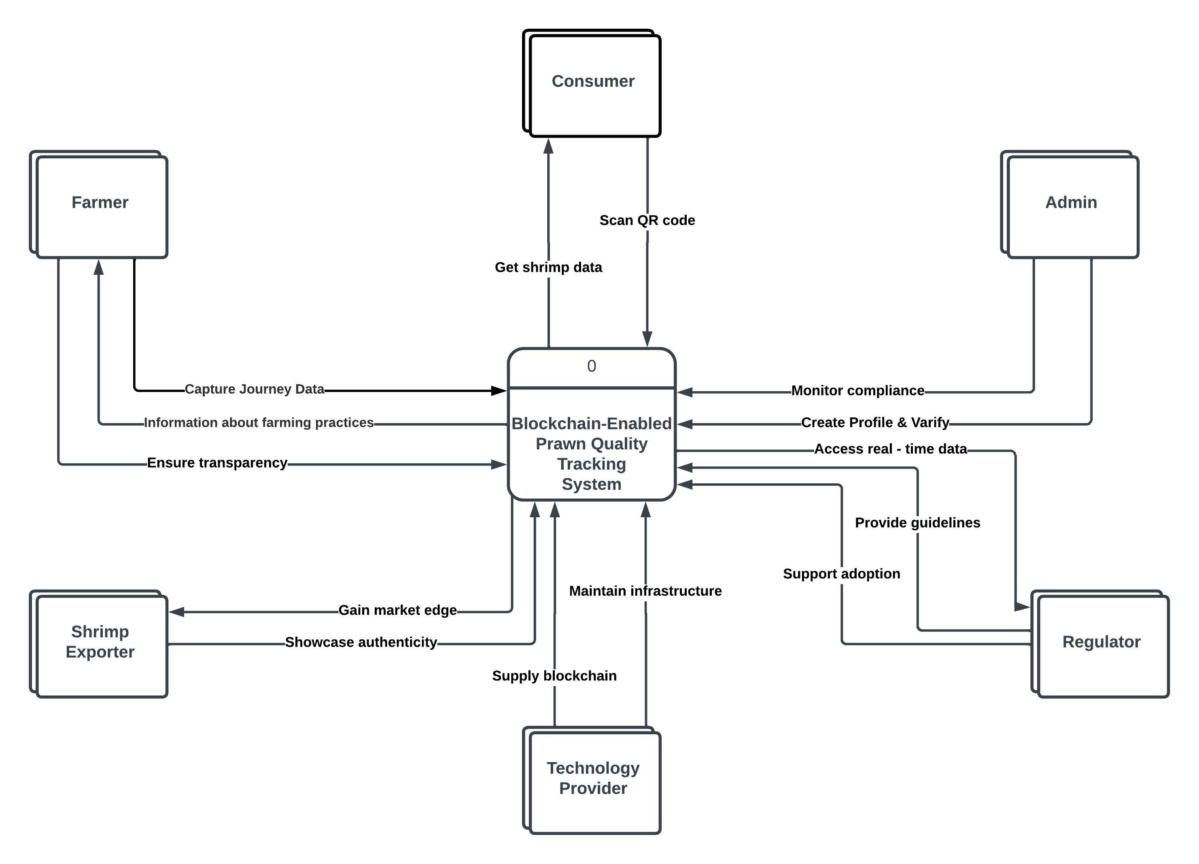

**Figure 19.1:** Context Level Data Flow Diagram

## Hardware detail (Include Rich Picture)

The “Blockchain-enabled prawn quality tracking system” would need a mix of hardware components to support the data collection, data processing, and communication required for its successful deployment. Here are some of the hardware components that could contribute to your project:

* **Smartphones:** Fishermen, suppliers, processors, and other stakeholders will utilize smartphones to gather and enter data into the system. These smartphones should be able to interface with QR code readers and smart stickers that support NFC.
* **QR Code Scanners**: Throughout the supply chain, QR code scanners will be used to read the codes on prawn items, providing stakeholders and customers with access to information about the product's provenance, certifications, and other pertinent facts.
* **Smart Sensors and IoT Devices:** These gadgets will be placed at different points along the supply chain to record information about the temperature, location, and handling circumstances.
* **Servers:** To manage data processing and storage, servers will host the blockchain network and related apps.

### Rich Picture:

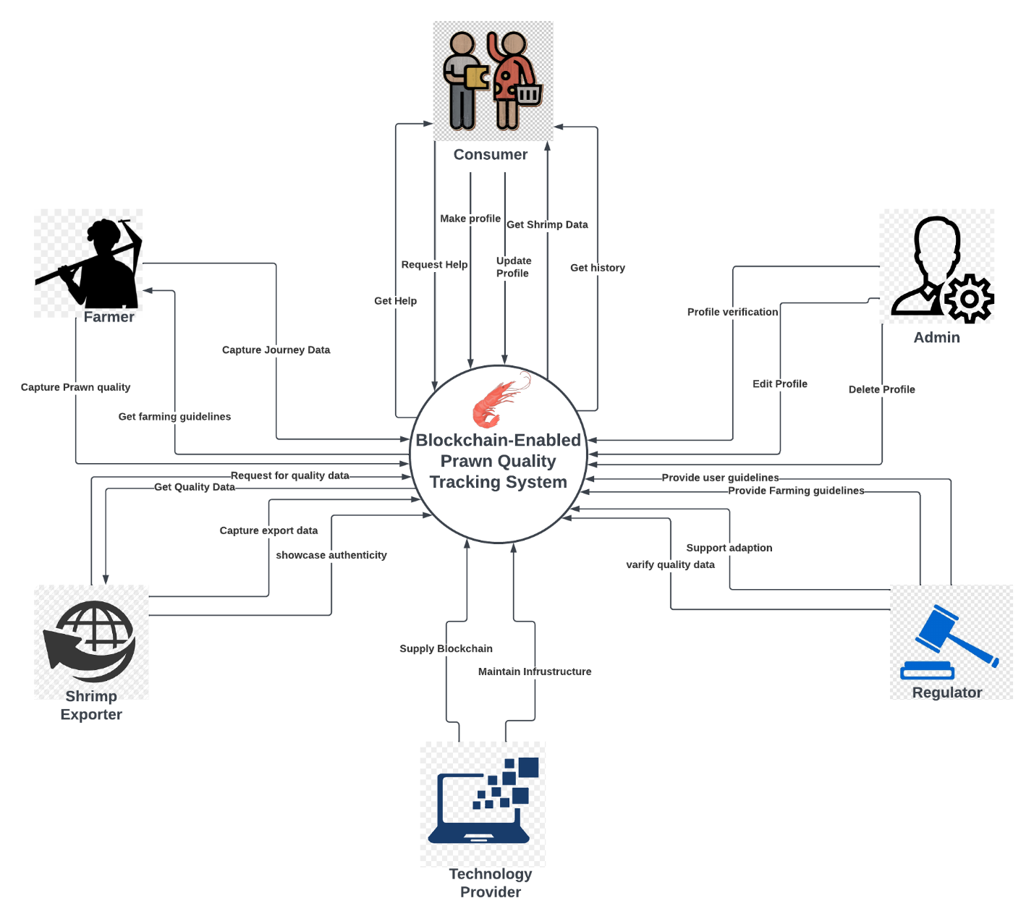

**Figure 9.1:** Rich Picture of the system

## Key Technical Features of Software

Here are some of the key technical features of our “Blockchain-enabled prawn quality tracking system” software:

* **Immutability:** The immutability of data saved on the blockchain ensures the integrity and validity of any information.
* **Transparency:** The supply chain will be more collaborative and trust-building because all stakeholders will have access to the same information.
* **Real-time Data Collection:** Real-time data will be gathered by smart sensors and IoT devices, giving current information on prawn conditions.
* **Decentralization:** The blockchain's decentralized design guarantees that no single party has control over the entire system, boosting security and resilience.
* **Smart Contract Automation:** Smart contracts will automate specific processes, reducing manual intervention and streamlining operations.
* **Secure Data Access:** To secure data access and safeguard sensitive information, the system will use cryptographic techniques.
* **Scalability:** The architecture will be created to support an expanding number of supply chain actors and transactions.
* **Digital Identity:** Each participant on the blockchain has a distinct digital identity, which promotes accountability and guarantees that only permitted parties can access the network and make contributions.
* **Data Analytics:** The program might include integrated or built-in data analytics tools to draw conclusions from the stored data. As a result, stakeholders' decisions can be better informed, and their operations can be optimized.
* **Mobile Accessibility**: Stakeholders can access and participate in the blockchain from a variety of devices, including smartphones and tablets, thanks to mobile apps or adaptable online interfaces.
* **Encryption and Security:** Using cryptographic methods, data is encrypted and guarded to keep critical information private and shielded from unauthorized access.

The prawn supply chain traceability project can create a reliable and effective system that benefits all stakeholders, from maintaining ethical fishing practices to providing consumers with knowledge about the items they buy, by concentrating on these particular crucial factors.

# Section 4:

## Information Gathering methods

Data collection is an integral part of developing software that accomplishes its goals. If we don’t consider the thoughts and ideas of the software’s users, we can’t meet their needs. I’ve chosen three effective ways to collect data for my system: stories, interviews and questionnaires.

### Story:

**(1).** It was a sunny morning and I was strolling through a busy fish market, mesmerized by the sight and sound of the ocean’s bounty. Out of the corner of my eye, I spied a display of gleaming shrimp, their shells shimmering like jewels from the depths. I couldn’t resist the temptation of a seafood feast and approached the vendor to take a closer look. My first thought was, are these shrimp really fresh? And if so, where did they come from? I was determined to get to the bottom of the mystery. I caught the vendor’s eye and asked him a question. His eyes lit up as he told me stories about fishing boats, far-off shores, and hauls in the early mornings. But while he was entertaining me, I had a nagging feeling that there should be a better way to track the origin of each shrimp. I came up with the idea of a “Shrimp Origins Tracking System”. With a newfound sense of purpose, I set out to build this system, motivated by the desire to share the stories behind our seafood. Every shrimp would have its own digital passport, eliminating any doubt about freshness or origin. My first fish market visit was fueled by curiosity. One misgivings turned into an adventure of discovery, leading to a more open and transparent seafood experience for everyone.

**Findings from Story:**

* The original encounter at the fish market brought to light a problem that is shared by many customers: the ambiguity around the provenance and freshness of seafood, in this case, prawns.
* It’s a sign that consumers don’t know enough about the seafood they’re buying.
* The vendor’s experience led to the development of the “Shrimp Origin Assurance System,” your solution to the problem you’re facing.

**(2).** On a warm summer afternoon, I found myself attending a lavish wedding reception at a picturesque coastal resort. As the party drew to a close, a beautiful spread of food was revealed. On one plate, I noticed a plate of shrimp cocktails. The shrimp were neatly arranged in glass bowls with an ice-covered base. The aroma of the shrimp tantalized my senses. My first thought was, Is this shrimp as fresh as it looks? I approached the buffet table with a bit of curiosity. As I picked up a shrimp, I looked at its texture and color to see if it was fresh. The more I examined it, the more I wondered where it came from. I decided to chat with the catering staff. I wanted to know more about where the shrimp came from and how they were handled. I asked one of the chefs about the shrimp and how they got to the banquet. The chef, wearing a white hat, told me that they got the shrimp that morning from local fishermen. He explained how they handled and prepared the seafood to make sure it was of the highest quality for their guests. While the chef’s explanation was comforting, I wondered if there was any way to independently verify his claims. That’s when an idea hit me. I remember reading about blockchain and its potential to make supply chains more transparent and traceable. What if blockchain could be used to track every step of a shrimp’s journey, from when it’s caught to when it arrives at your wedding reception?

**Findings from Story:**

* A common concern shared by consumers – the uncertainty about the freshness and quality of seafood, even in upscale settings.
* The doubts about the shrimp's freshness and origin, despite the appealing presentation, indicate a lack of transparency and information available to consumers.
* The experience with the shrimp buffet sparked the idea of using blockchain technology to address the lack of transparency in the seafood industry.

### Interviewing:

In order to understand our stakeholders better, we decided to meet them. In the interview, we presented our app and explained how it works. We asked a mix of open and closed ended questions. We used the Pyramid method to organize the questions. We asked questions based on the user’s perspectives and insights on the issues they faced while buying sweets. This information helps us to understand what our users need and how our solution can meet their needs. By having these conversations with the users we hope to get a better idea of what they need from our application. It is important to understand our users and what their interests are so that we can decide if they will use our System.

**Interview: Local Consumer**

1. How frequently do you consume prawn?
2. Do you know about blockchain technology?
3. What are some of the features that you want to see in the prawn blockchain application?
4. How much do you care about traceability and traceability of the prawn products’ origin?
5. Do you want to pay more for the prawn products that have verified traceability based on blockchain?
6. How do you feel about the app’s UI and design? Any ideas for improvements?
7. How easy is the app to use?
8. How satisfied are you with the prawn product’s quality information, freshness and sourcing?

**Interview: Retailer**

1. How do you think a blockchain-based prawn traceability solution could benefit your retail business?
2. How easy is it to use the retailer features in the app?
3. What features would you like to see in the app that would help you manage your inventory and sales better?
4. How much importance do you attach to the accuracy of the information that the app provides in your sales plan?
5. How likely is it that you would recommend this app to your network of retailers?
6. What elements of the app’s design and interface are most attractive or need to be improved?
7. How happy are you with how the app supports managing returns and handling customer inquiries?

**Interview: Distributor**

1. How has the adoption of a blockchain solution affected your prawn distribution processes?
2. What is your opinion on the app’s ability to offer real-time visibility of product movement?
3. Have you encountered any difficulties integrating the blockchain data into your distributed systems?
4. What additional features could improve your distribution efficiency inside the app?
5. What is the importance of data accuracy and information flow in your distribution processes?
6. How does the app help you coordinate with different stakeholders in your supply chain?
7. How satisfied are you with the customer service of the app?
8. Does the app solve problems related to stock management and demand forecasting?

### Questionnaire:

Using Google Forms, we created an online questionnaire and sent out invites to the general public and some of our stakeholders to answer a series of questions about sweets. The answers we got from each participant will allow us to quickly and easily assess the public’s preferences. In addition, the survey allowed us to collect specific information about the challenges people face while searching for investors.

### Survey Form:

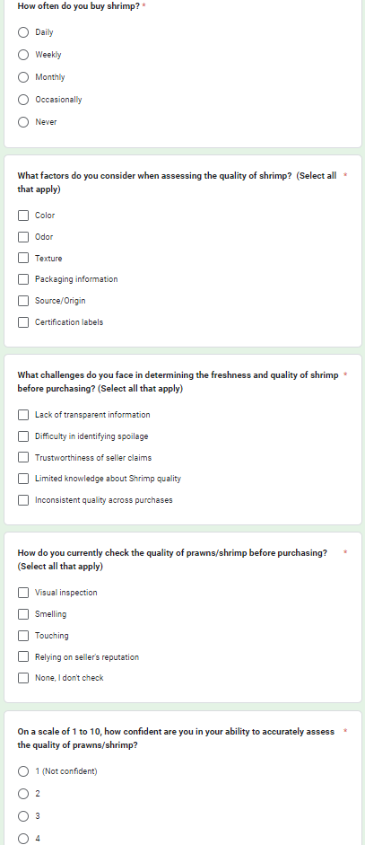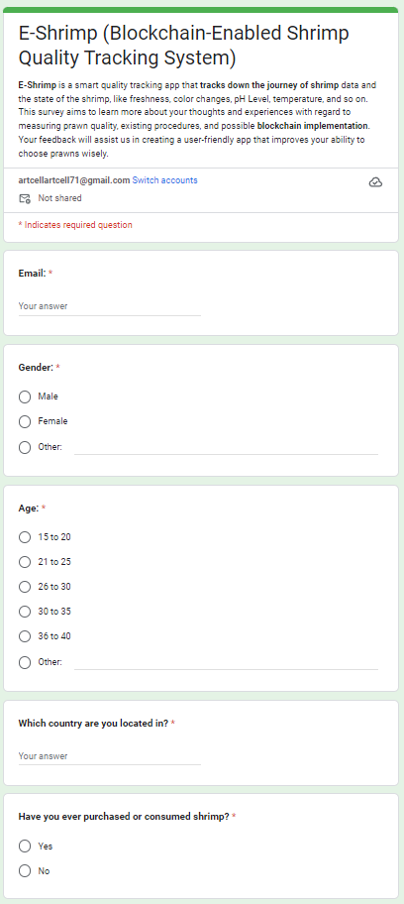

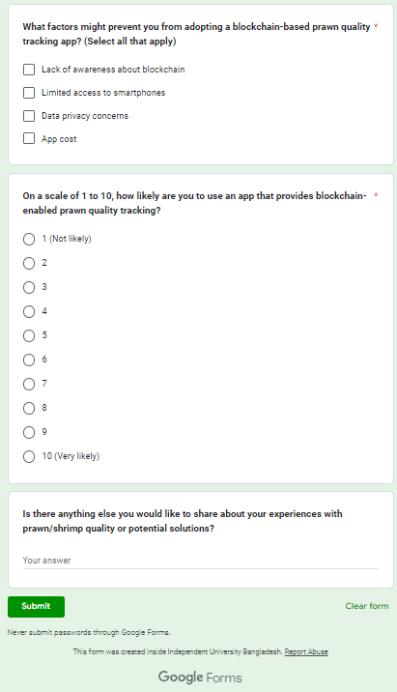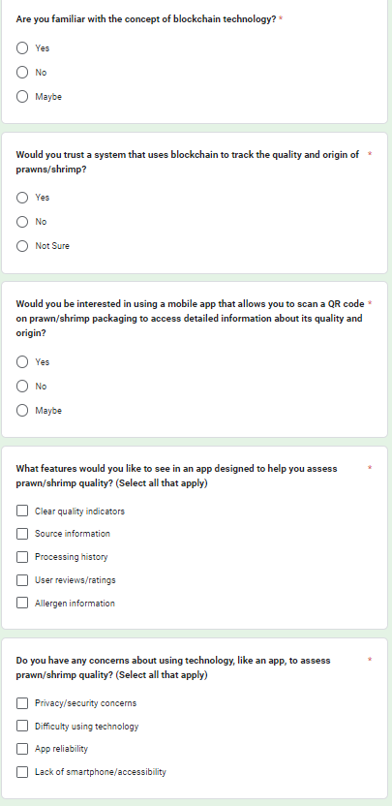

### Survey Result:

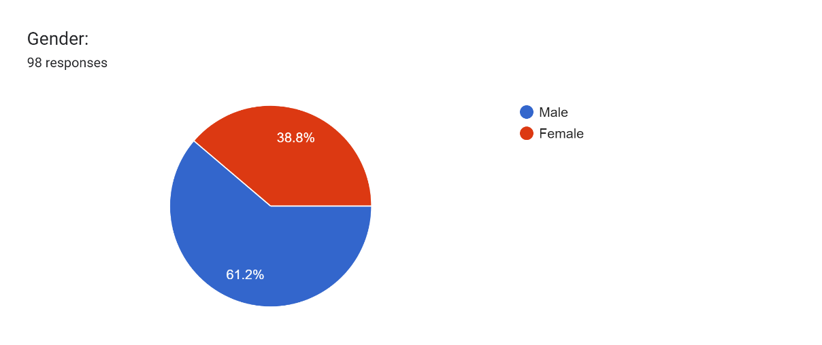

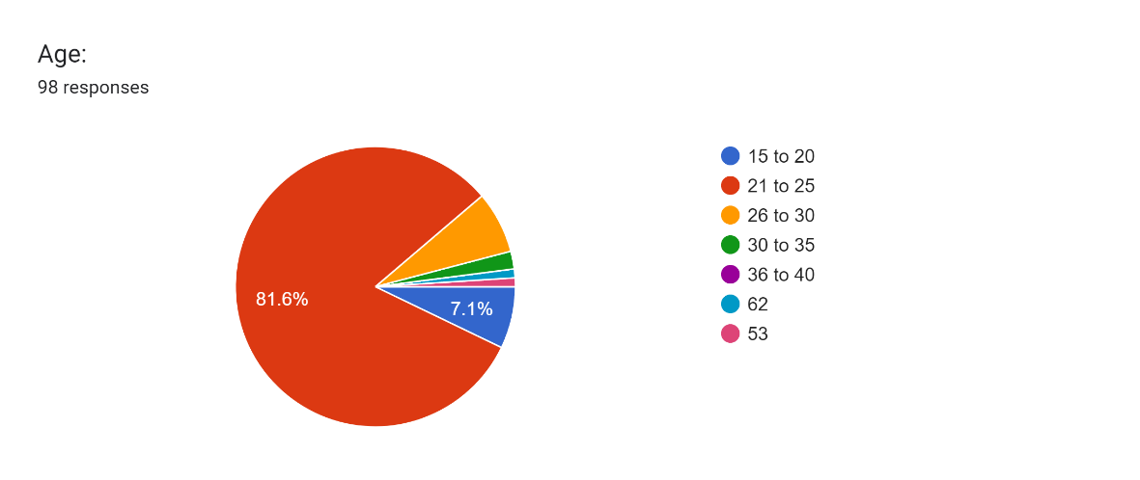

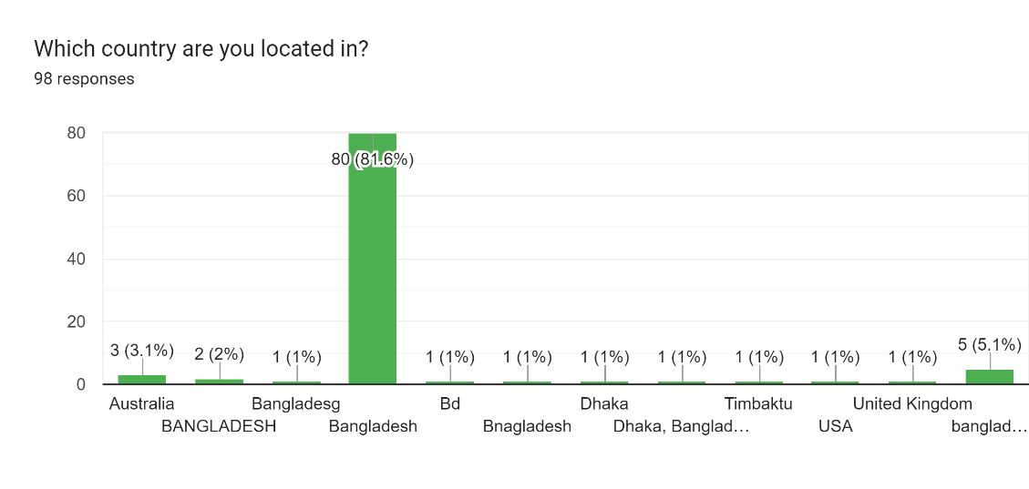

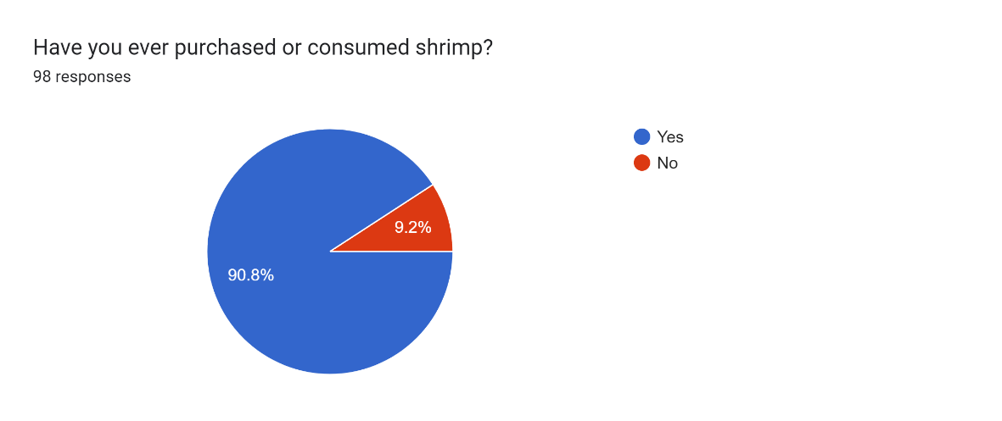

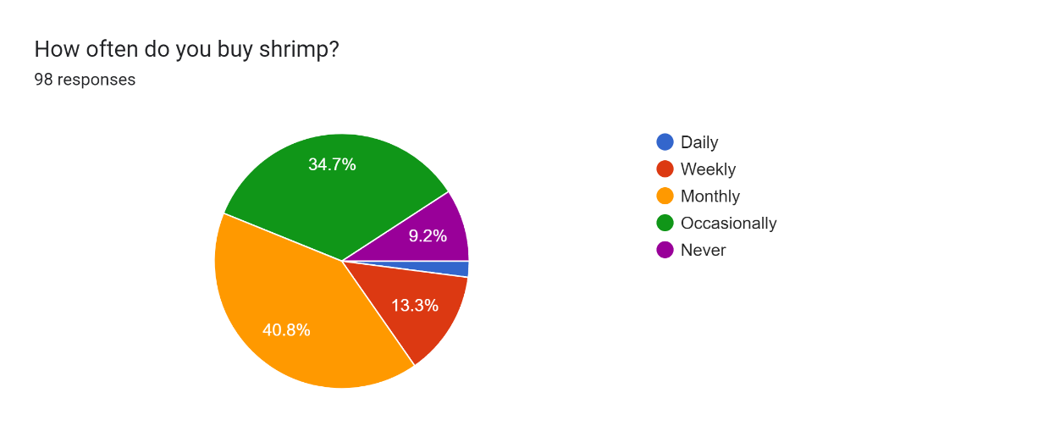

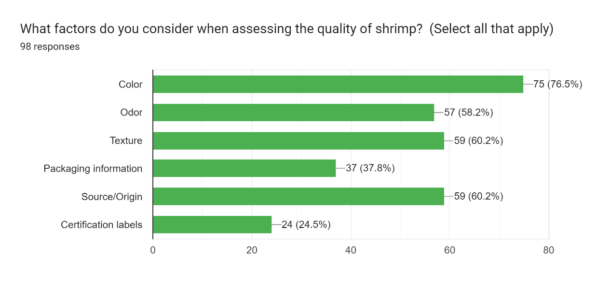

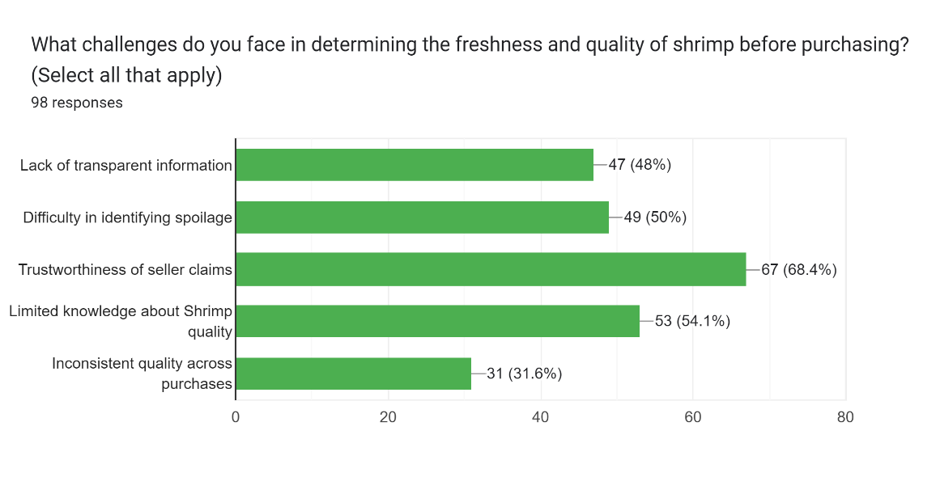

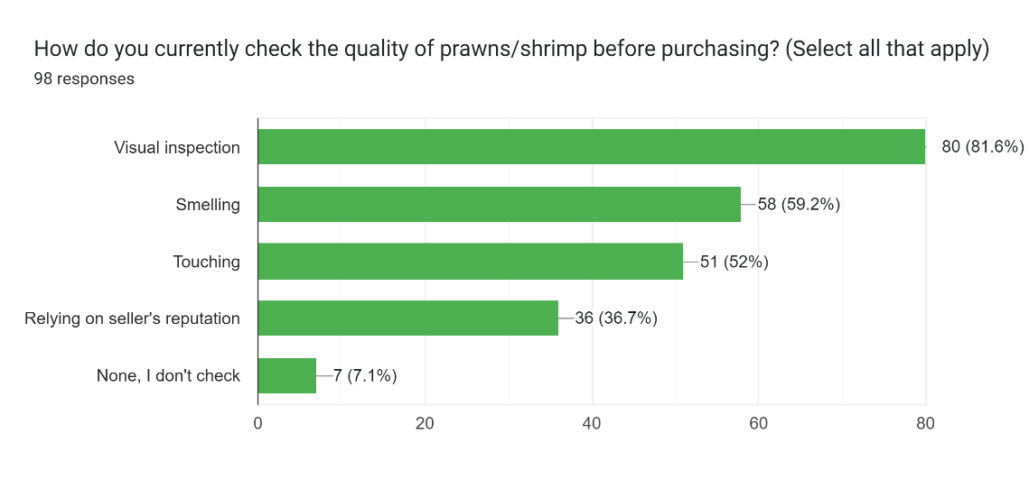

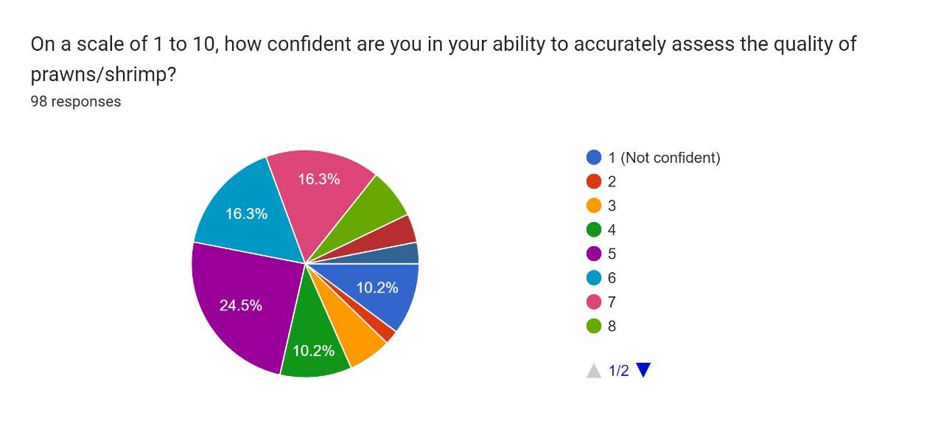

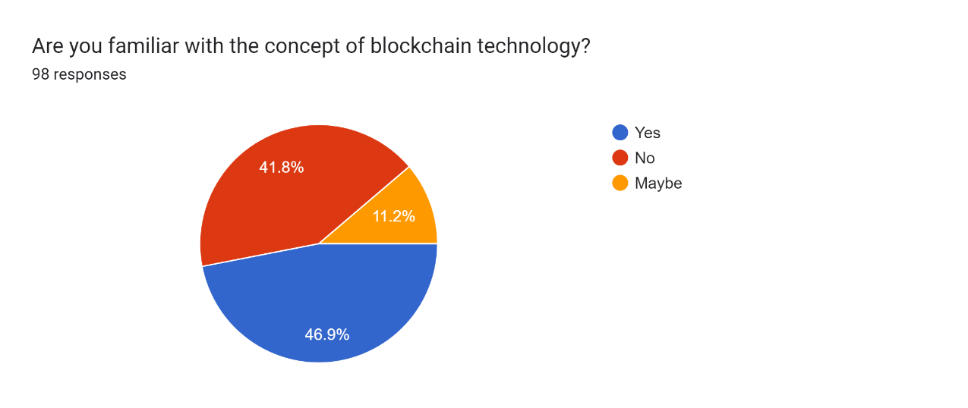

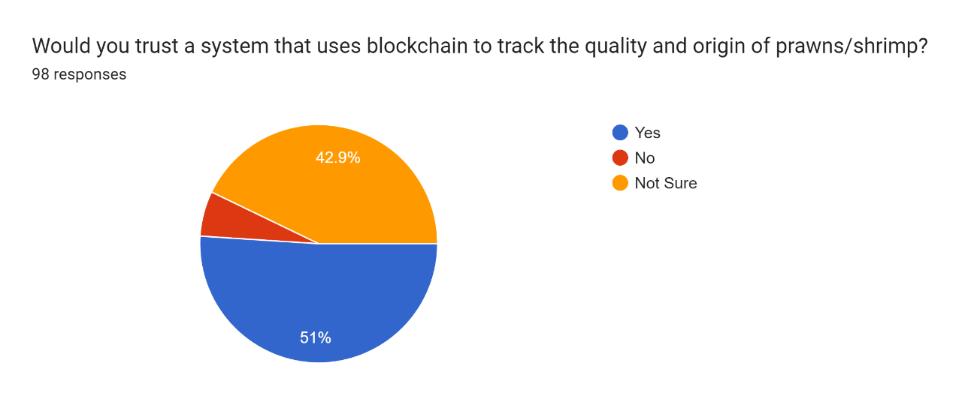

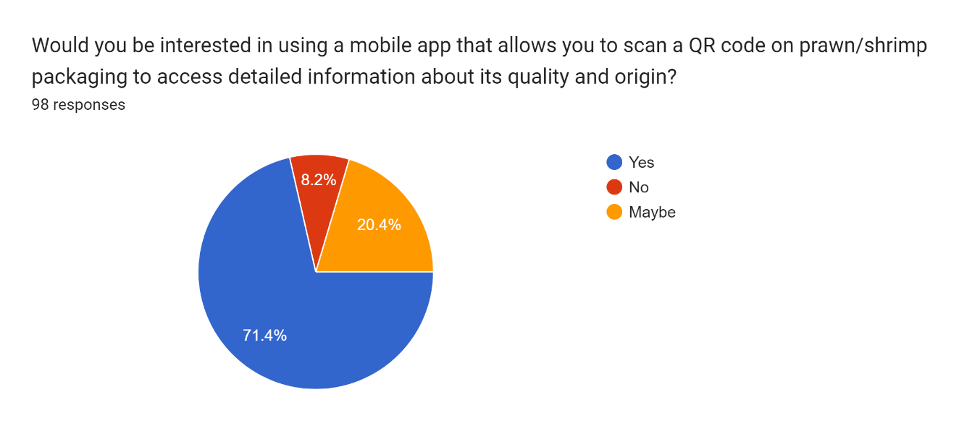

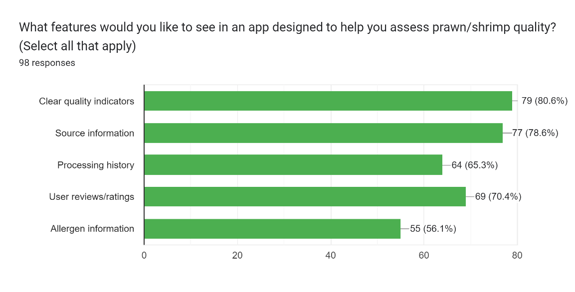

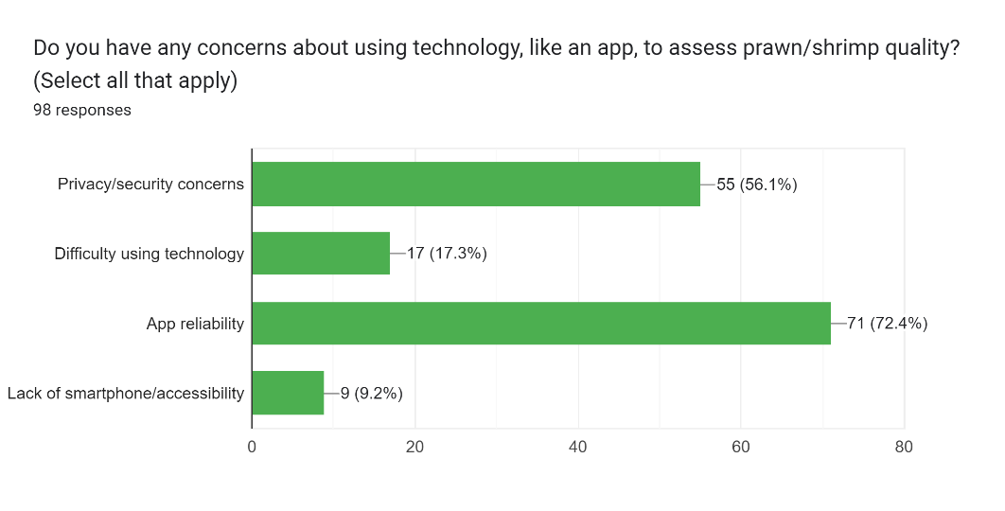

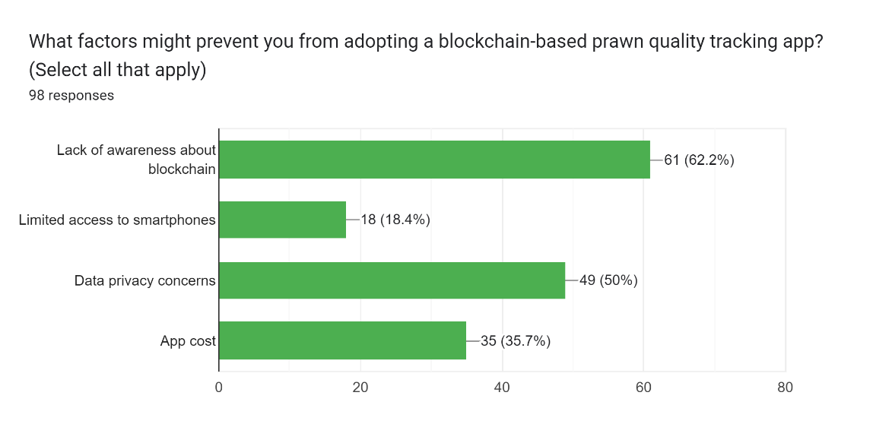

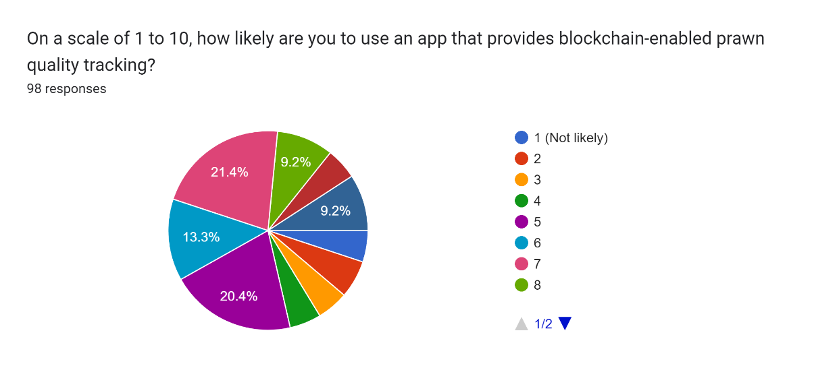

## Major functionalities offered by the system

Here are some major functionalities that your "Blockchain-Enabled Prawn Quality Tracking System" could offer:

* **Product Data Recording:** Give farmers and other interested parties the ability to enter information about prawn quality, including where they came from, when they were harvested, how they were processed, and any certifications. Keep records of data that are tamper- and immutable-proof on the blockchain.
* **Real-Time Tracking:** Use RFID/NFC technology to enable stakeholders to follow the movement and location of prawn batches in real time across the supply chain. Showcase the prawn's trip with interactive timelines or maps.
* **Quality Verification:** Automated smart contracts should be used to evaluate prawn quality based on predetermined standards. Set off alarms and messages when quality criteria are not being met.
* **Transparency and Traceability:** Make the entire prawn supply chain visible so that customers may obtain in-depth details on the product's journey.
* **Consumer Access:** Allow customers to access product details, such as source information and quality, by scanning QR codes on prawn packaging.
* **Data Analytics and Reporting:** Create reports and analytics based on historical information about prawn quality to assist stakeholders in spotting patterns and taking wise decisions.
* **Regulatory Compliance:** By keeping correct records and offering auditable trails for inspections, you may make it easier for people to abide by food safety rules.
* **User Management and Authentication:** Control user permissions and roles to make sure that only people with the proper access may view and change data.
* **Data Privacy and Security:** Protect critical data about prawn quality by implementing encryption and cutting-edge security techniques.

Together, these features support the system's capacity to improve transparency, traceability, and quality assurance throughout the prawn supply chain, fostering confidence among stakeholders and customers alike.

## Use Case Diagram

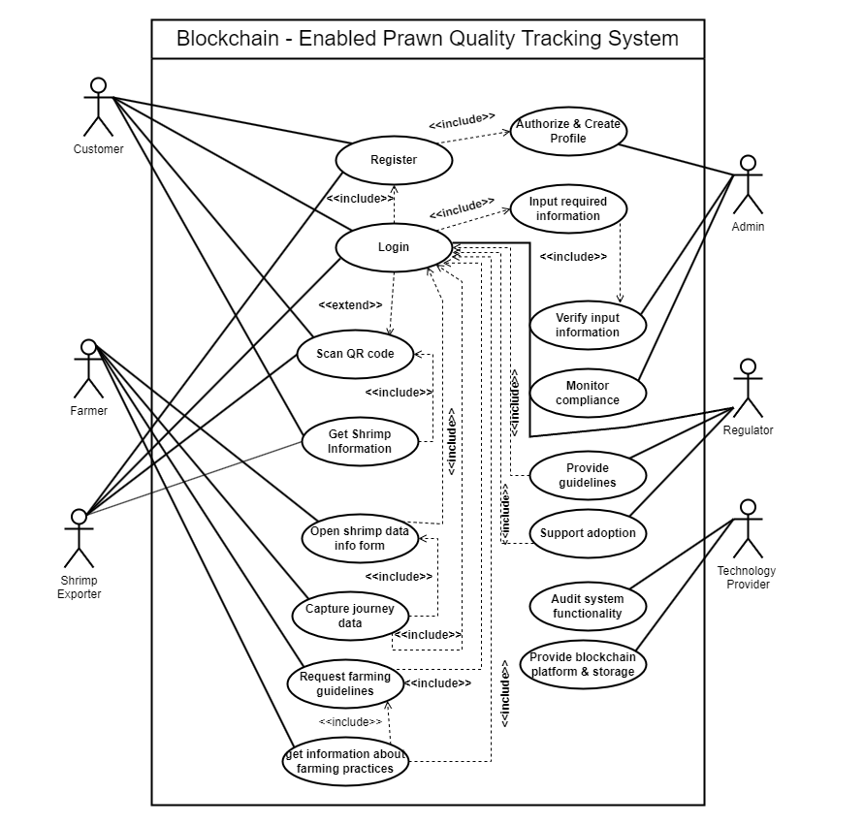

**Figure 13.1:** Use Case Diagram

## Normal Scenarios

### 14.1 Scenario 1

|  |  |  |
| --- | --- | --- |
| **Use case name:** | Register | UniqueID: SA-00001 |
| **Area:** | Blockchain-Enabled Prawn Quality Tracking System. | |
| **Actor(s):** | Customer, Exporter, Regulator. | |
| **Stakeholder:** | Customer, Exporter, Regulator, Admin. | |
| **Description:** | User registers in the app as Customer, Regulator or Distributor. | |
| **Triggering Event:** | User inputs required information and click register button. | |
| **Trigger type:** | External. | |
| **Steps Performed (Main Path):** | | **Information for Steps:** |
| 1. The registration interface loads. | |  |
| 1. Selects user type. | | User wants to register as customer, Regulator or Distributor |
| 1. User enters the following information: Email, User type, username, mobile Number, address, password etc. | | Personal information of user like User type, username, Mobile Number, password, email, password. |
| 1. Clicks the submit button. | | All required information must be filled up. |
| 1. If all information is correct then user will be registered to the system. | |  |
| 1. A unique id will be given to the user and a confirmation message will be shown to the user interface. | | Unique id and a confirmation message. |
| **Preconditions:** | User needs to have idea about the features of the app. | |
| **Postconditions:** | User must carefully input all required information while registering. | |
| **Assumptions:** | User wants to use the app. | |
| **Success Guarantee:** | Participant has registered for login and create an account. | |
| **Minimum Guarantee:** | Participant was able to login. | |
| **Requirements Met:** | Allow users to be able to register for the login using a secure Web site. | |
| **Outstanding Issues:** | Track multiple product at a time. | |
| **Priority:** | High. | |
| **Risk:** | Medium. | |

### 14.2 Scenario 2

|  |  |  |
| --- | --- | --- |
| **Use case name:** | Login | UniqueID: SA-00002 |
| **Area:** | Blockchain-Enabled Prawn Quality Tracking System. | |
| **Actor(s):** | Customer, Exporter, Regulator, Admin. | |
| **Stakeholder:** | Customer, Exporter, Regulator, Admin. | |
| **Description:** | User Login in the app as Customer, Regulator or Distributor. | |
| **Triggering Event:** | User inputs Email, Password and click register button. | |
| **Trigger type:** | External. | |
| **Steps Performed (Main Path):** | | **Information for Steps:** |
| 1. The login interface loads. | |  |
| 1. Selects user type. | | User wants to login as customer, Regulator or Distributor |
| 1. User enters the following information: Email and password. | | At first input email address, then enter password. |
| 1. Clicks the login button. | | All required information must be filled up. |
| 1. If all information is correct then user will be login to the app. | |  |
| **Preconditions:** | User needs to have idea about the features of the app. | |
| **Postconditions:** | User must carefully input email and password while Login. | |
| **Assumptions:** | User wants to check some products. | |
| **Success Guarantee:** | Participant has login and check the products authenticity. | |
| **Minimum Guarantee:** | Participant was able to login. | |
| **Requirements Met:** | Allow users to be able to login using a secure Web site. | |
| **Outstanding Issues:** | Track multiple product at a time. | |
| **Priority:** | High. | |
| **Risk:** | Low. | |

### 14.3 Scenario 3

|  |  |  |
| --- | --- | --- |
| **Use case name:** | Scan QR Code | UniqueID: SA-00003 |
| **Area:** | Blockchain-Enabled Prawn Quality Tracking System. | |
| **Actor(s):** | Customer, Exporter, Regulator. | |
| **Stakeholder:** | Customer, Exporter, Regulator. | |
| **Description:** | User Scan QR code for check the products authenticity. | |
| **Triggering Event:** | User Click “Open Scanner” and scan the QR code. | |
| **Trigger type:** | External. | |
| **Steps Performed (Main Path):** | | **Information for Steps:** |
| 1. The Dashboard interface loads. | |  |
| 1. Click Open Scanner button. | |  |
| 1. Camera will be open to scan the QR code. | | A QR code will be scanned instantly . |
| 1. A windows will be open that indicating authenticity of the shrimp information include Freshness Percentage, Temperature, PH Level, Color Changes, Harvesting time and so on. | |  |
| **Preconditions:** | User needs a smart phone with build in camera. | |
| **Postconditions:** | User must carefully input all required information while registering. | |
| **Assumptions:** | User wants to use the app. | |
| **Success Guarantee:** | Participant has registered for login and create an account. | |
| **Minimum Guarantee:** | Participant was able to login. | |
| **Requirements Met:** | Allow users to be able to register for the login using a secure Web site. | |
| **Outstanding Issues:** | Track multiple product at a time. | |
| **Priority:** | High. | |
| **Risk:** | Medium. | |

### 14.4 Scenario 4

|  |  |  |
| --- | --- | --- |
| **Use case name:** | Provide Guidelines | UniqueID: SA-00004 |
| **Area:** | Blockchain-Enabled Prawn Quality Tracking System. | |
| **Actor(s):** | Regulator. | |
| **Stakeholder:** | Regulator, Farmer. | |
| **Description:** | Regulator will provide guidelines for farmers about harvesting the shrimp. | |
| **Triggering Event:** | User Input the guideline data and click submit button. | |
| **Trigger type:** | External. | |
| **Steps Performed (Main Path):** | | **Information for Steps:** |
| 1. The dashboard interface loads. | |  |
| 1. Selects provide guidelines. | |  |
| 1. Select type of guidelines. | | Attach the valuable data that include guidelines. |
| 1. Clicks the submit button. | | Required data must be filled up. |
| 1. A pop up will be showed following “Guideline submitted successfully” | |  |
| **Preconditions:** | User needs to have idea about the features and steps of the app. | |
| **Postconditions:** | User must carefully input required data. | |
| **Assumptions:** | User wants to provide guidelines about harvesting the shrimp. | |
| **Success Guarantee:** | Participant has submitted the necessary file and get a pop up notification. | |
| **Minimum Guarantee:** | Participant has submitted the files. | |
| **Requirements Met:** | Allow users to be able to regulate the app using a secure Web site. | |
| **Outstanding Issues:** | Track multiple product at a time. | |
| **Priority:** | High. | |
| **Risk:** | Low. | |

## Alternate Scenarios

### 4.1 Scenario 1

|  |  |  |
| --- | --- | --- |
| **Use case name:** | Register | UniqueID: SA-00001 |
| **Area:** | Blockchain-Enabled Prawn Quality Tracking System. | |
| **Actor(s):** | Customer, Exporter, Regulator. | |
| **Stakeholder:** | Customer, Exporter, Regulator, Admin. | |
| **Description:** | User registers in the app as Customer, Regulator or Distributor. | |
| **Triggering Event:** | User inputs required information and click register button. | |
| **Trigger type:** | External. | |
| **Steps Performed (Main Path):** | | **Information for Steps:** |
| 1. The registration interface loads. | |  |
| 1. Selects user type. | | User wants to register as customer, Regulator or Distributor |
| 1. User enters the following information: Email, User type, username, mobile Number, address, password etc. | | Personal information of user like User type, username, Mobile Number, password, email, password. |
| 1. Clicks the submit button. | | All required information must be filled up. |
| 1. If any information is not correct then an error message will be shown that information is not valid and which information is invalid is also shown. Then prompted to enter valid information. | | Error message, invalid information. |
| 1. The user will enter correct information and continue with the registration. | | Correct information. |
| 1. A unique id will be given to the user and a confirmation message will be shown to the user interface. | | Unique id and a confirmation message. |
| **Preconditions:** | User needs to have idea about the features of the app. | |
| **Postconditions:** | User must carefully input all required information while registering. | |
| **Assumptions:** | User wants to use the app. | |
| **Success Guarantee:** | Participant has registered for login and create an account. | |
| **Minimum Guarantee:** | Participant was able to login. | |
| **Requirements Met:** | Allow users to be able to register for the login using a secure Web site. | |
| **Outstanding Issues:** | Track multiple product at a time. | |
| **Priority:** | High. | |
| **Risk:** | Medium. | |

### 4.2 Scenario 2

|  |  |  |
| --- | --- | --- |
| **Use case name:** | Login | UniqueID: SA-00002 |
| **Area:** | Blockchain-Enabled Prawn Quality Tracking System. | |
| **Actor(s):** | Customer, Exporter, Regulator, Admin. | |
| **Stakeholder:** | Customer, Exporter, Regulator, Admin. | |
| **Description:** | User Login in the app as Customer, Regulator or Distributor. | |
| **Triggering Event:** | User inputs Email, Password and click register button. | |
| **Trigger type:** | External. | |
| **Steps Performed (Main Path):** | | **Information for Steps:** |
| 1. The login interface loads. | |  |
| 1. Selects user type. | | User wants to login as customer, Regulator or Distributor |
| 1. User enters the following information: Email and password. | | At first input email address, then enter password. |
| 1. If any information is not correct then an error message will be shown that information is not valid and which information is invalid is also shown. Then prompted to enter valid information. | | Error message, invalid information. |
| 1. The user will enter correct information and clicks the login button. | | Correct information. |
| 1. If all information is correct then user will be login to the app. | |  |
| **Preconditions:** | User needs to have idea about the features of the app. | |
| **Postconditions:** | User must carefully input email and password while Login. | |
| **Assumptions:** | User wants to check some products. | |
| **Success Guarantee:** | Participant has login and check the products authenticity. | |
| **Minimum Guarantee:** | Participant was able to login. | |
| **Requirements Met:** | Allow users to be able to login using a secure Web site. | |
| **Outstanding Issues:** | Track multiple product at a time. | |
| **Priority:** | High. | |
| **Risk:** | Low. | |

### 4.3 Scenario 3

|  |  |  |
| --- | --- | --- |
| **Use case name:** | Scan QR Code | UniqueID: SA-00003 |
| **Area:** | Blockchain-Enabled Prawn Quality Tracking System. | |
| **Actor(s):** | Customer, Exporter, Regulator. | |
| **Stakeholder:** | Customer, Exporter, Regulator. | |
| **Description:** | User Scan QR code for check the products authenticity. | |
| **Triggering Event:** | User Click “Open Scanner” and scan the QR code. | |
| **Trigger type:** | External. | |
| **Steps Performed (Main Path):** | | **Information for Steps:** |
| 1. The Dashboard interface loads. | |  |
| 1. Click Open Scanner button. | |  |
| 1. Camera will be open to scan the QR code. | | A QR code will be scanned instantly . |
| 1. If the user can’t have internet access at that time, then the scan will fail. | | Error message. |
| 1. After reconnecting the internet, the code will be scanned in an instant. | |  |
| 1. A windows will be open that indicating authenticity of the shrimp information include Freshness Percentage, Temperature, PH Level, Color Changes, Harvesting time and so on. | |  |
| **Preconditions:** | User needs a smart phone with build in camera. | |
| **Postconditions:** | User must carefully input all required information while registering. | |
| **Assumptions:** | User wants to use the app. | |
| **Success Guarantee:** | Participant has registered for login and create an account. | |
| **Minimum Guarantee:** | Participant was able to login. | |
| **Requirements Met:** | Allow users to be able to register for the login using a secure Web site. | |
| **Outstanding Issues:** | Track multiple product at a time. | |
| **Priority:** | High. | |
| **Risk:** | Medium. | |

### 4.4 Scenario 4

|  |  |  |
| --- | --- | --- |
| **Use case name:** | Provide Guidelines | UniqueID: SA-00004 |
| **Area:** | Blockchain-Enabled Prawn Quality Tracking System. | |
| **Actor(s):** | Regulator. | |
| **Stakeholder:** | Regulator, Farmer. | |
| **Description:** | Regulator will provide guidelines for farmers about harvesting the shrimp. | |
| **Triggering Event:** | User Input the guideline data and click submit button. | |
| **Trigger type:** | External. | |
| **Steps Performed (Main Path):** | | **Information for Steps:** |
| 1. The dashboard interface loads. | |  |
| 1. Selects provide guidelines. | |  |
| 1. Select type of guidelines. | | Attach the valuable data that include guidelines. |
| 1. If the selected type cannot match the file format, then an error message will be shown that the file format does not match, and which format can be valid is also shown. | | Error message. |
| 1. The user will enter correct data format and continue the process. | | Correct information. |
| 1. Clicks the submit button. | | Required data must be filled up. |
| 1. A pop up will be showed following “Guideline submitted successfully” | |  |
| **Preconditions:** | User needs to have idea about the features and steps of the app. | |
| **Postconditions:** | User must carefully input required data. | |
| **Assumptions:** | User wants to provide guidelines about harvesting the shrimp. | |
| **Success Guarantee:** | Participant has submitted the necessary file and get a pop up notification. | |
| **Minimum Guarantee:** | Participant has submitted the files. | |
| **Requirements Met:** | Allow users to be able to regulate the app using a secure Web site. | |
| **Outstanding Issues:** | Track multiple product at a time. | |
| **Priority:** | High. | |
| **Risk:** | Low. | |

## Functional Requirements

Functional requirements outline the specific functionalities and capabilities that the shrimp blockchain system should possess to fulfill the needs of stakeholders. A few functional specifications for the shrimp blockchain project are listed below:

* Users can create accounts, including producers, exporters, regulators, retailers, and consumers.
* Authenticate users when they log in to the system.
* Admin can see and control the users. Like added or delete a user.
* Farmers can input catch journey data, including location, time, quantity, and fishing method.
* QR codes provide consumers with access to prawn journey details through scanning and shrimp quality can be tracked.
* The system enables real-time updates of prawn data throughout the supply chain.
* Regulatory authorities have access to audit and verify data as needed.
* Regulators can provide guidelines about shrimp farming practices.
* The system offers user guides and support resources to assist users in understanding its functionalities.
* Technology Providers can audit system functionality and check whether the system working perfectly or not.

## Non-Functional Requirements

Non-functional requirements define the qualities and characteristics that the shrimp blockchain system should possess to ensure its effectiveness, security, and user experience. Here are some specifications for the shrimp blockchain project that are not functional:

**Security and Privacy:**

* To protect sensitive data stored on the blockchain, the system needs to include strong encryption measures.
* To avoid unauthorized access to prawn data, strict user authentication and permission procedures should be used.
* To protect user privacy, compliance with data protection laws such as GDPR should be guaranteed.

**Performance and Scalability:**

* A large number of transactions should be processed by the blockchain system without a noticeable performance hit.
* The system's response time should stay within reasonable bounds as both the number of users and the volume of data grows.
* A high level of dependability is required for the system in order to reduce downtime and guarantee reliable access to the data.
* Mechanisms for redundancy and failover ought to be set up to deal with probable system breakdowns.

**Usability and User Experience:**

* The user interface of the blockchain application should be simple to use and accommodating to users of different technological backgrounds.
* Actions taken inside the program should respond quickly, resulting in a smooth user experience.

**Auditability and Transparency:**

* For the objectives of accountability and transparency, every action taken within the system should be recorded and auditable.
* Smart contracts' modifications, transaction histories, and access logs ought to be saved and accessible.

**Compliance with Standards:**

* Industry requirements for data security, blockchain technology, and data exchange protocols should be followed by the system.
* Additionally, it must adhere to all applicable laws, rules, and guidelines for the prawn business as well as for online transactions.

**Resilience and Disaster Recovery:**

* In the event of system failures or natural disasters, the system should have systems in place for data backup, recovery, and continuity.

Section 5:

## Entity Relationship Diagram

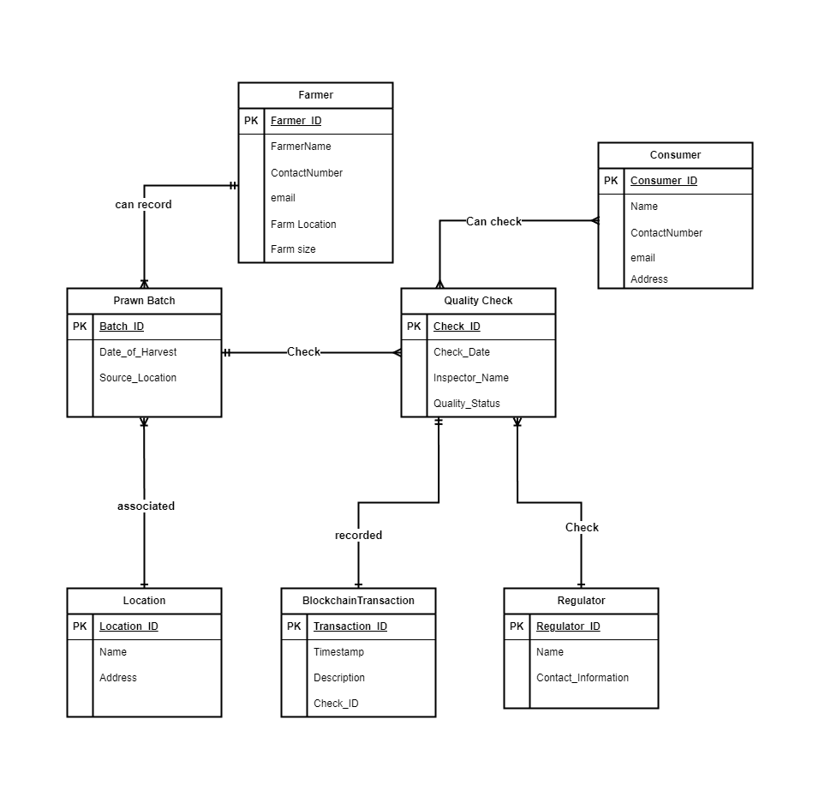

**Figure 18.1:** Entity Relationship Diagram for Blockchain-Enabled Prawn Quality Tracking System

## Logical Data Flow diagram

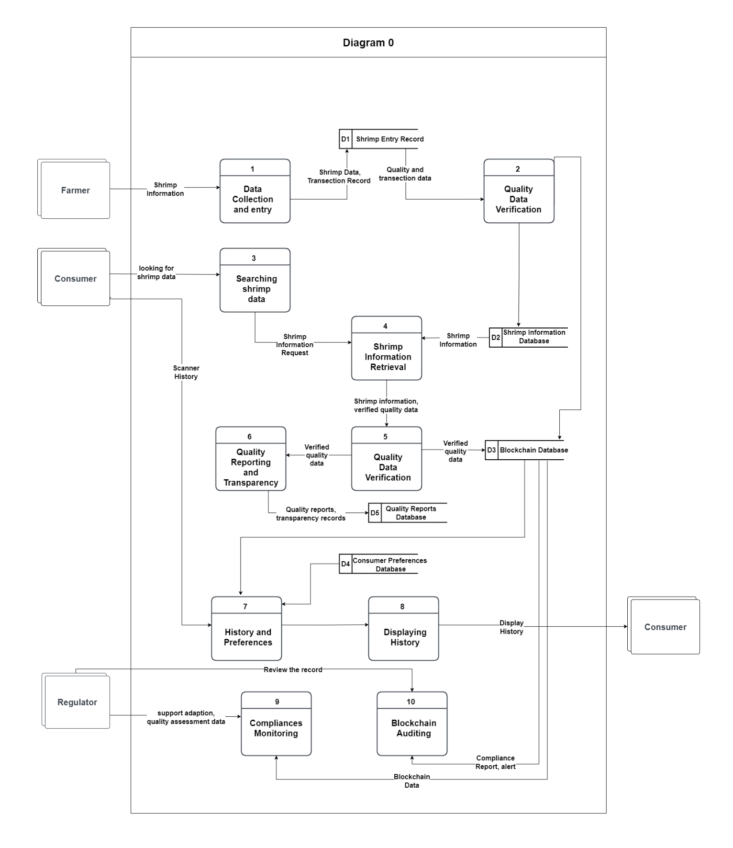

**Figure 19.1:** Logical Data Flow diagram 0

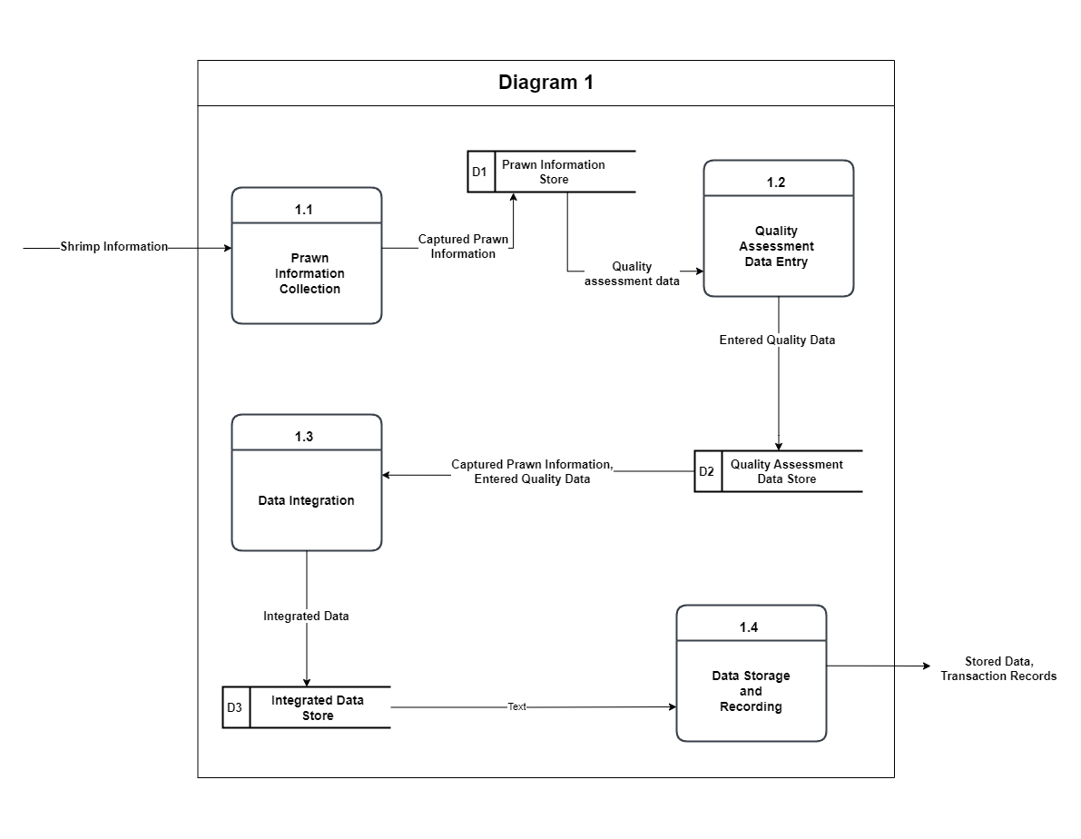

**Figure 19.2:** Logical Data Flow diagram 1

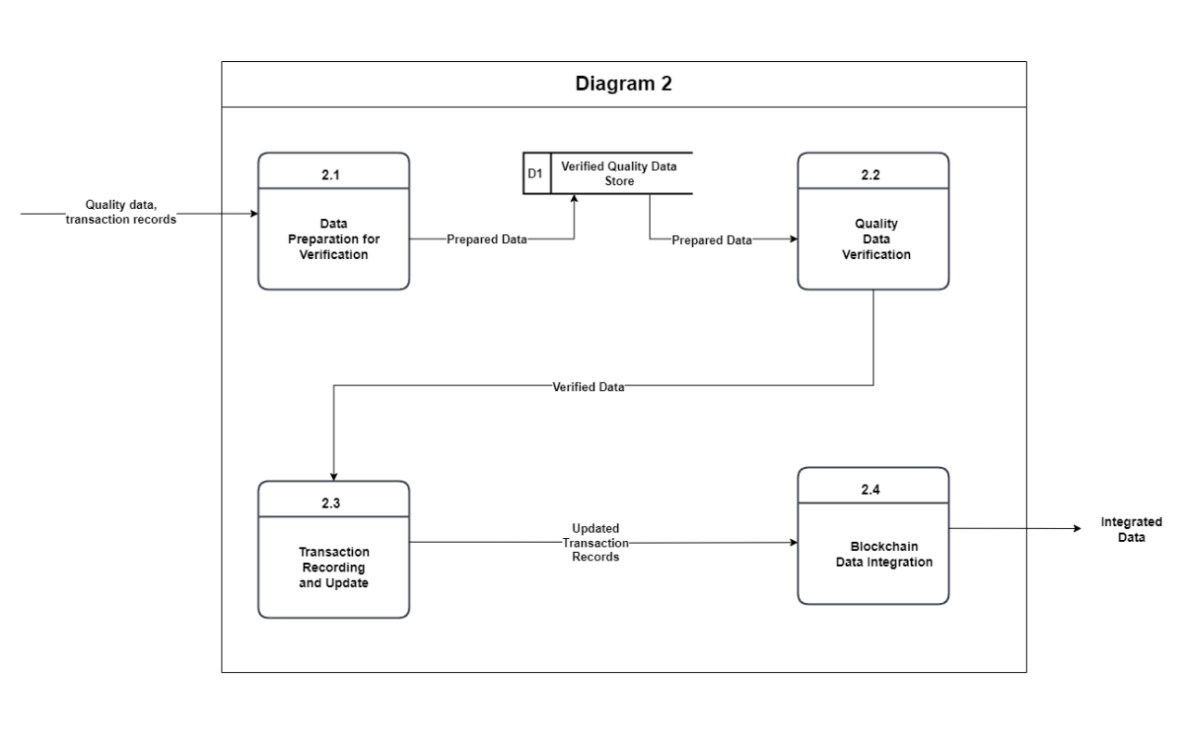

**Figure 19.3:** Logical Data Flow diagram 2

## Physical Data Flow diagram

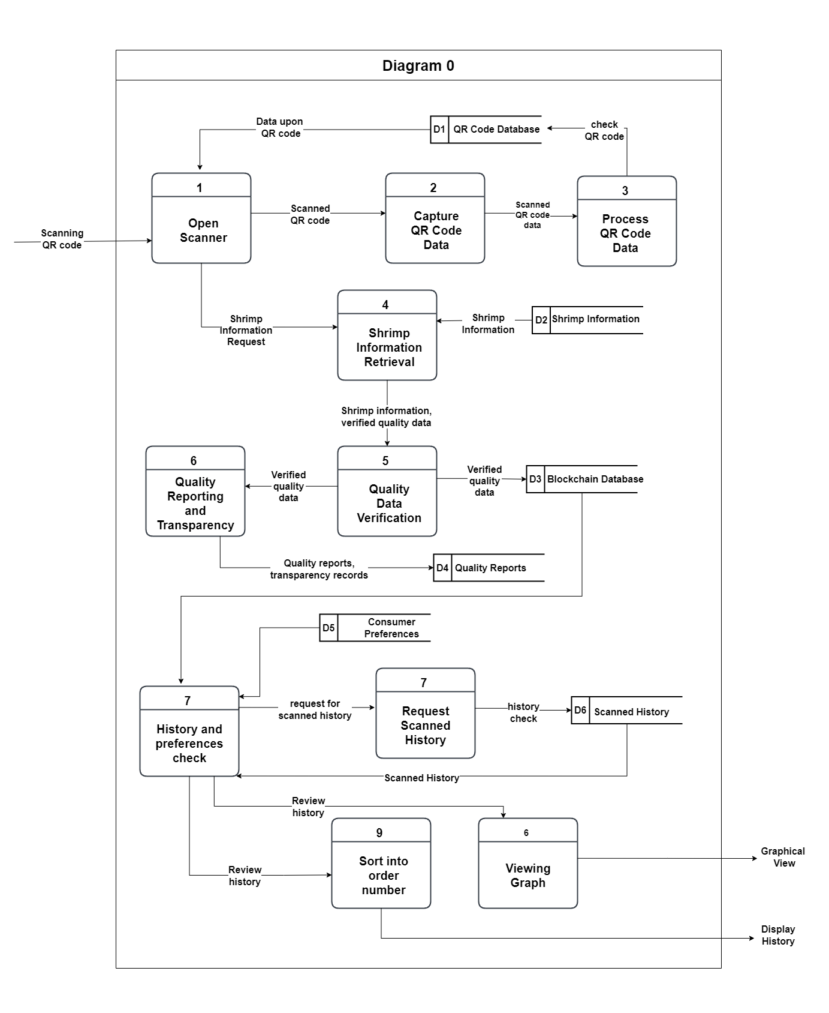

**Figure 3.1:** Physical Data Flow diagram 0

## Activity diagrams

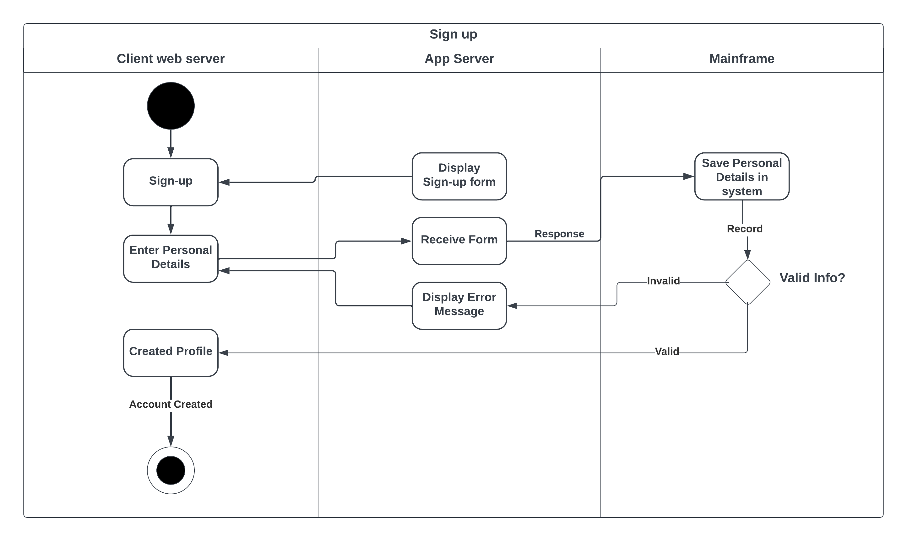

**Figure 21.1:** Activity diagram (Sign-Up)

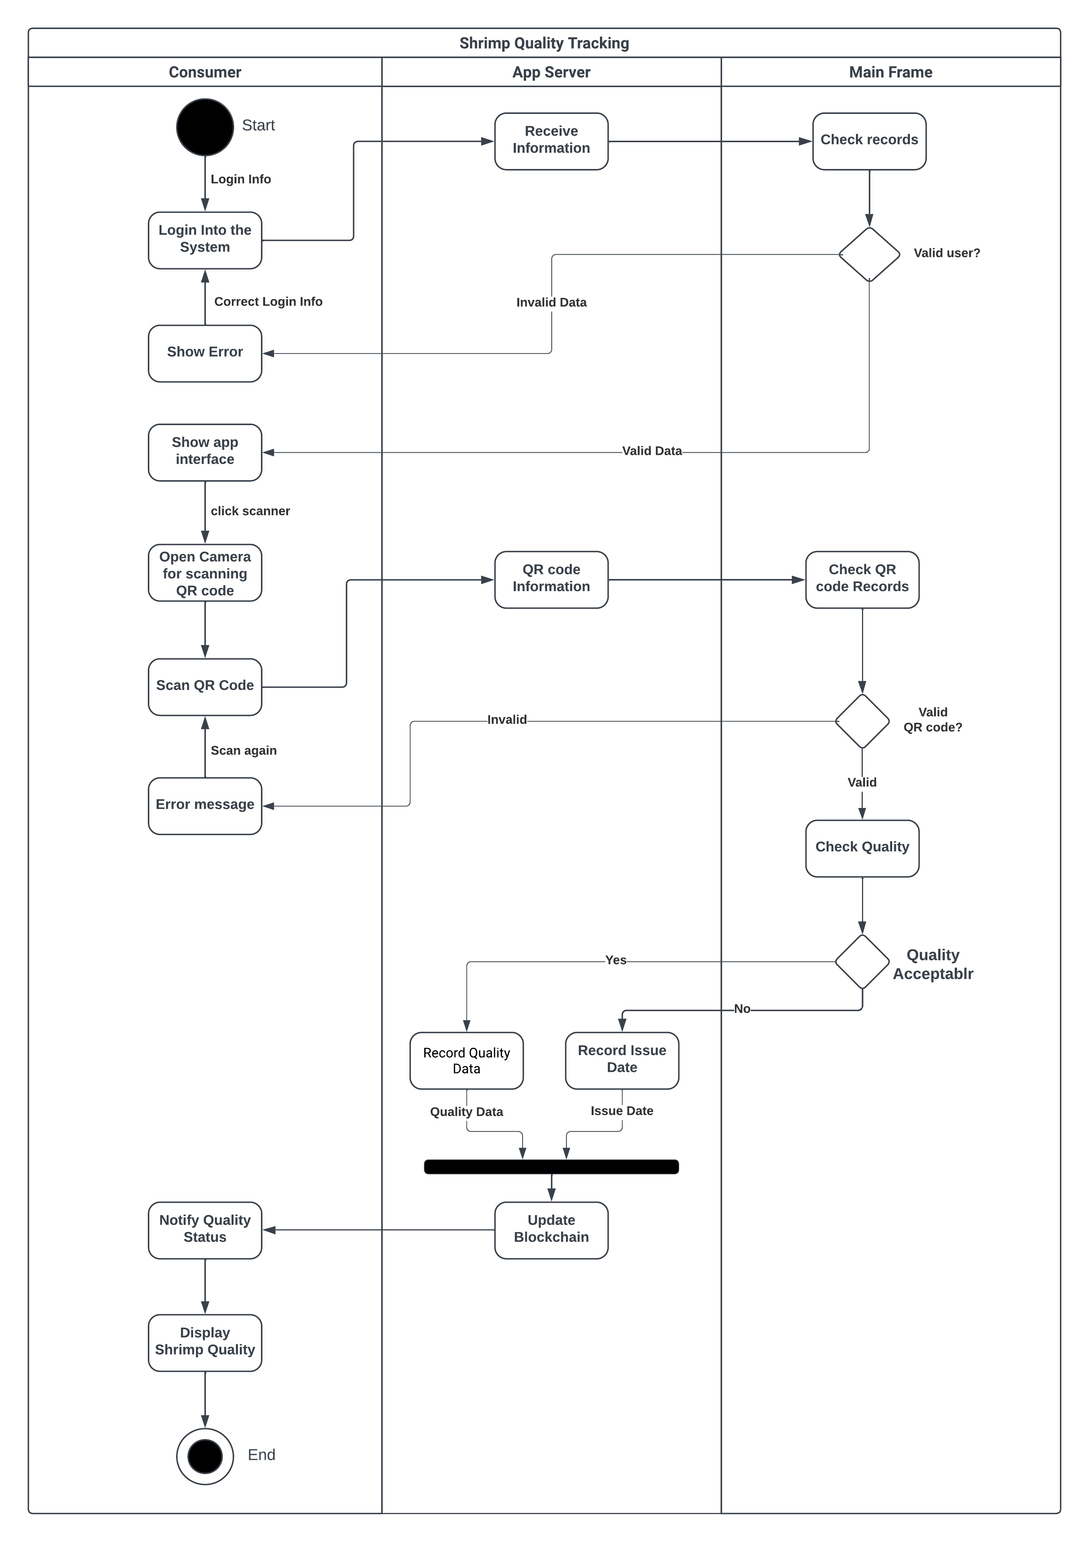

**Figure 21.2:** Activity diagram (Shrimp Quality Tracking)

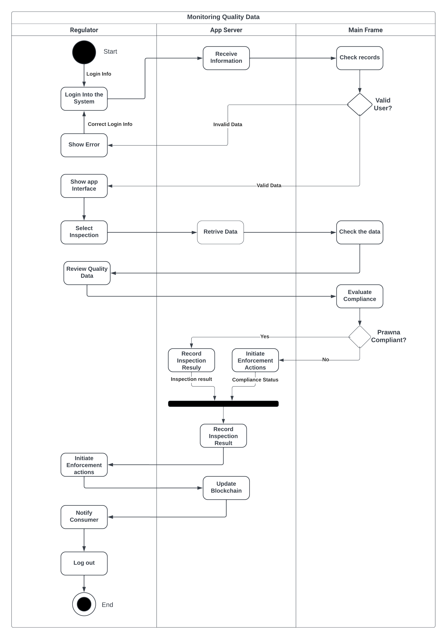

**Figure 21.3:** Activity diagram (Monitoring Quality Data)

## Sequence diagrams

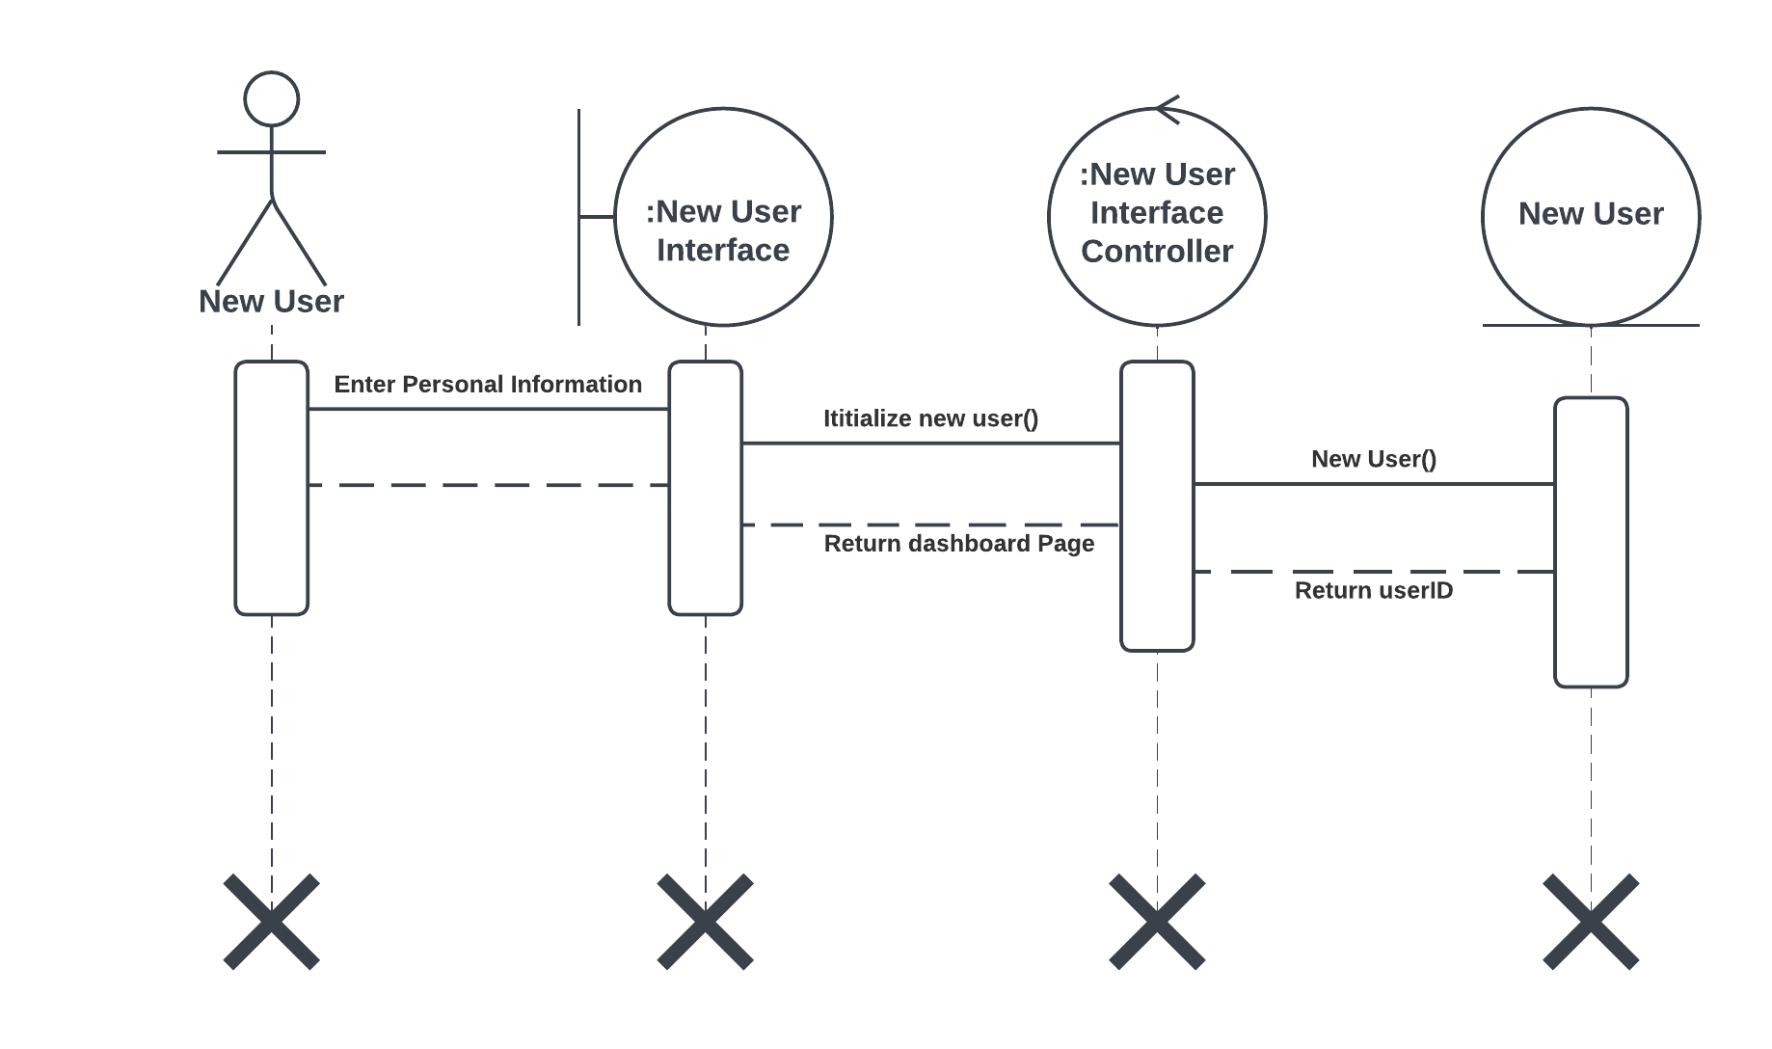

**Figure 22.1:** Sequence diagram (Sign-up)

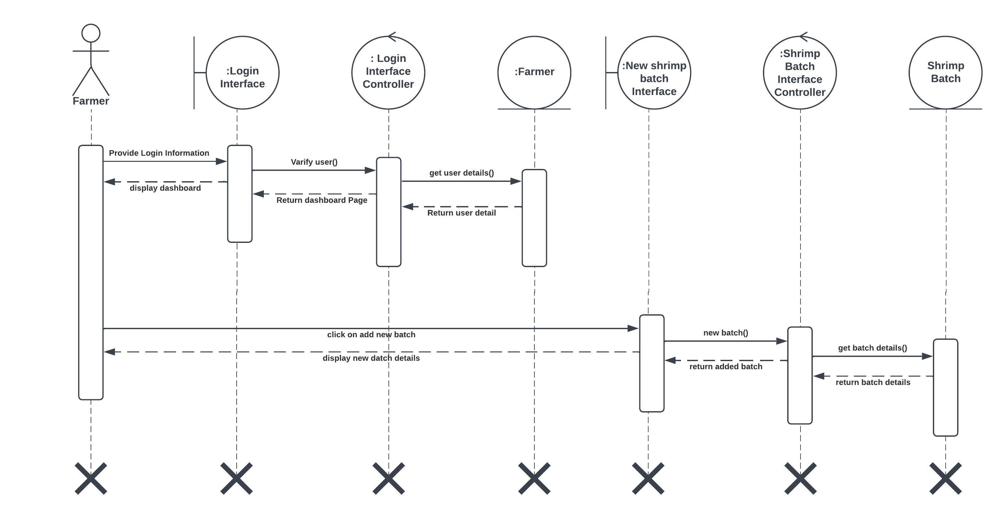

**Figure 22.2:** Sequence diagram (Add data for New Shrimp batch)

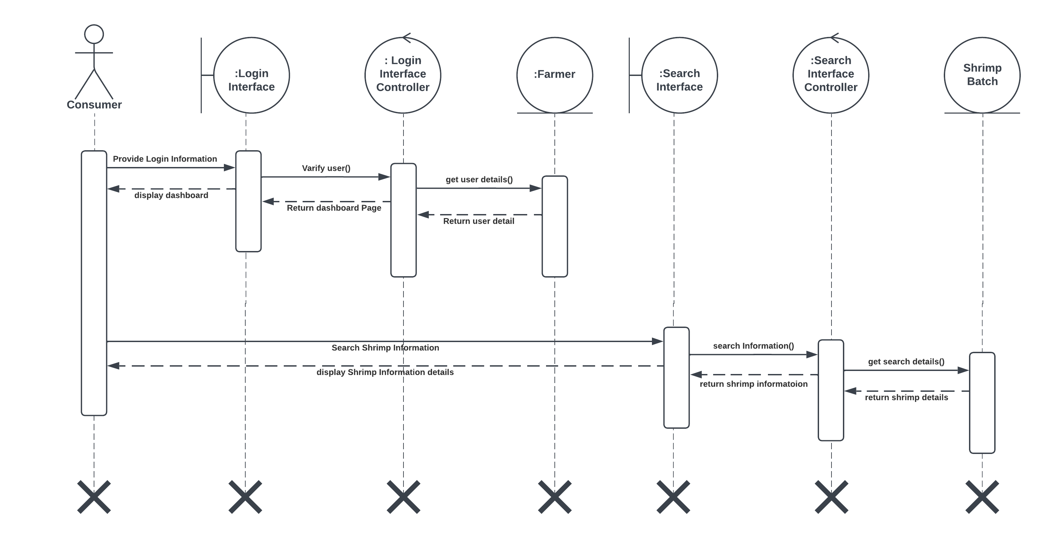

**Figure 22.3:** Sequence diagram (Search for Shrimp Information)

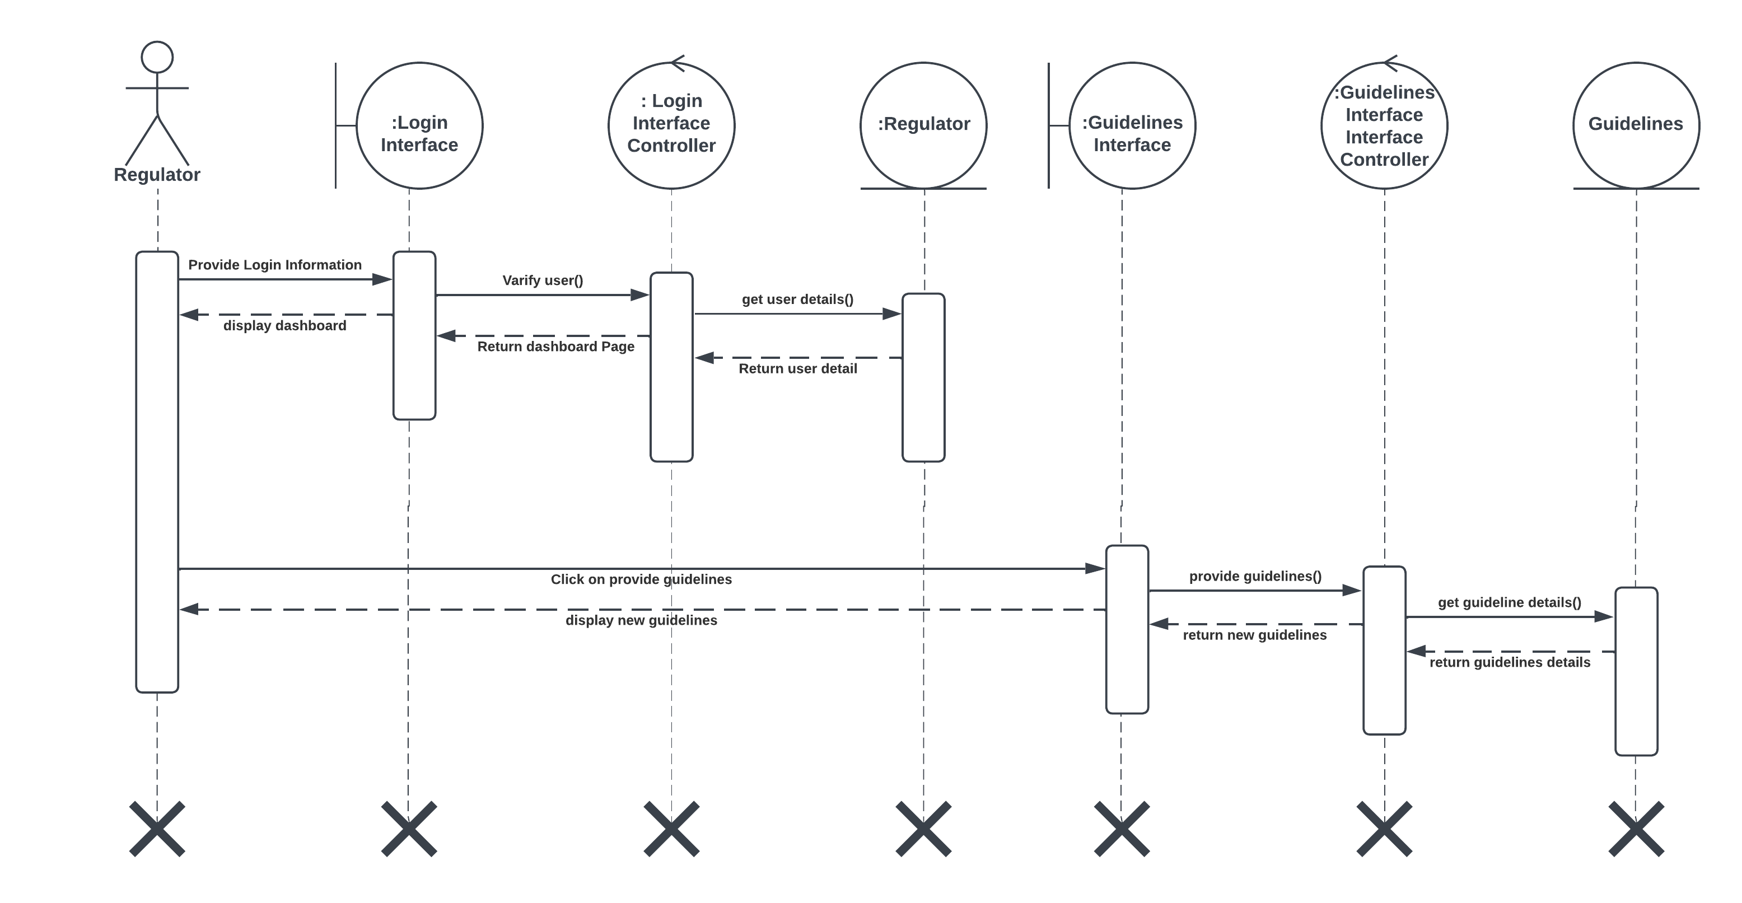

**Figure 22.4:** Sequence diagram (Provide Guidelines)

## Communication diagrams

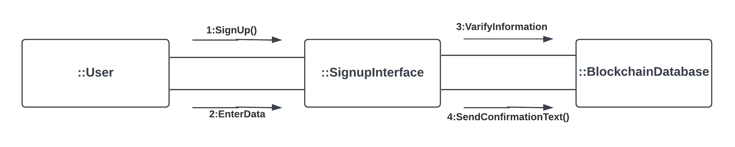

**Figure 23.1:** Communication diagram (Sign-up)

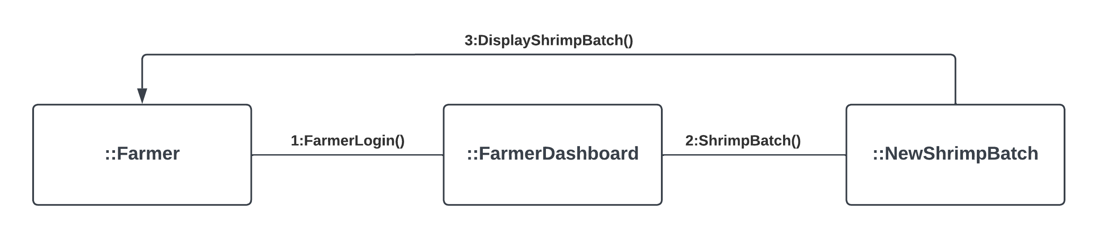

**Figure 23.2:** Communication diagram (Add data for New Shrimp batch)

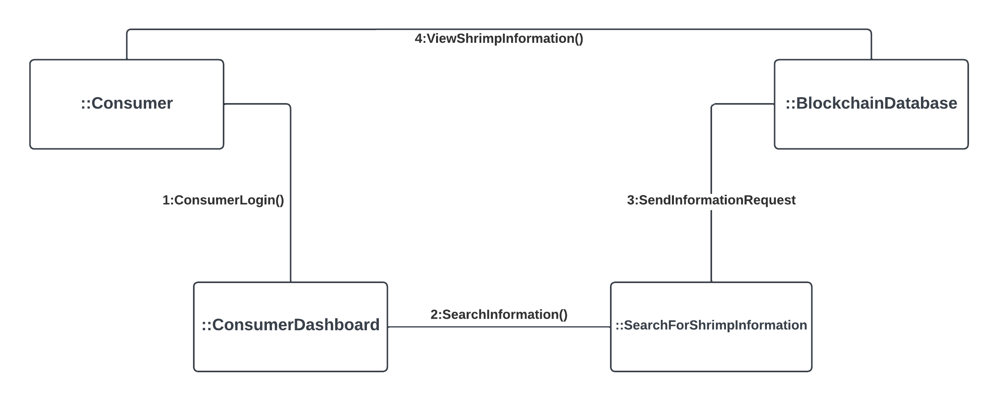

**Figure 23.3:** Communication diagram (Search for Shrimp Information)

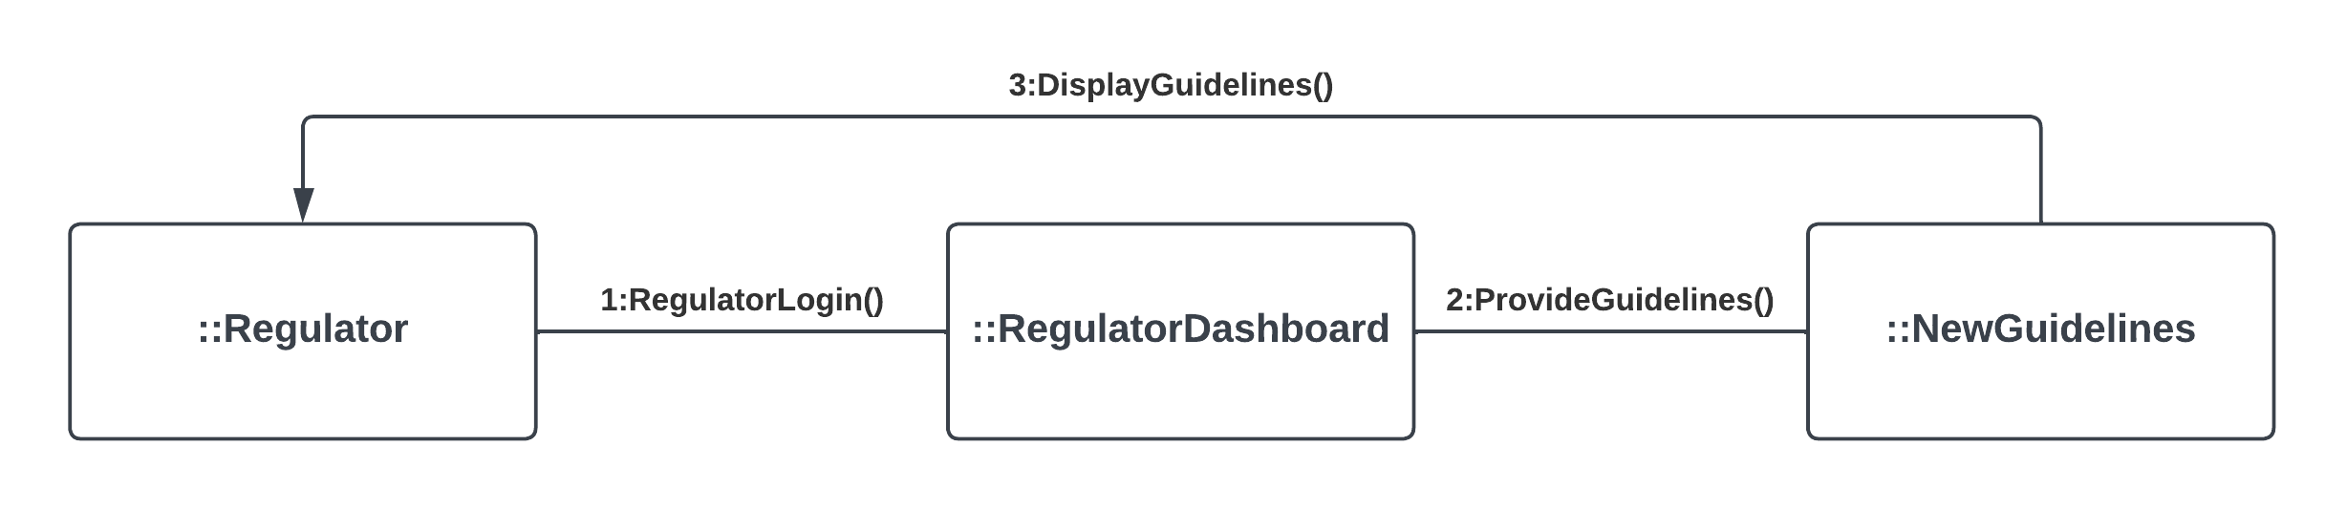

**Figure 23.4:** Communication diagram (Provide Guidelines)

## Class diagrams

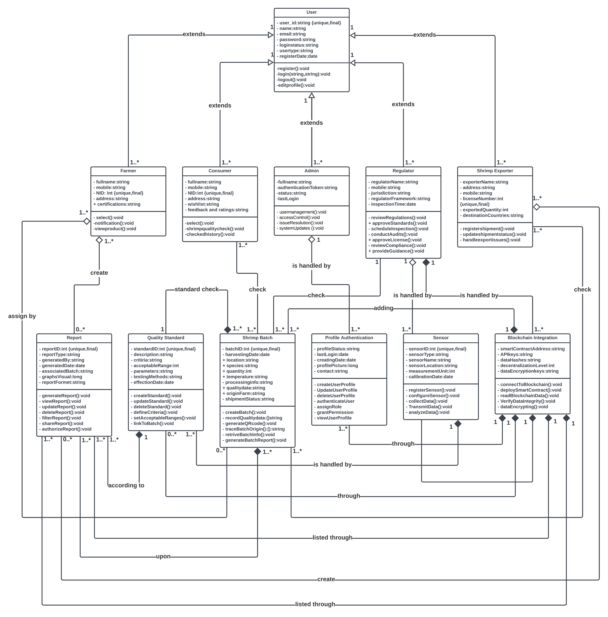

**Figure 24.1:** Class Diagram for Blockchain-Enabled Prawn Quality Tracking System

## State-chart diagrams.

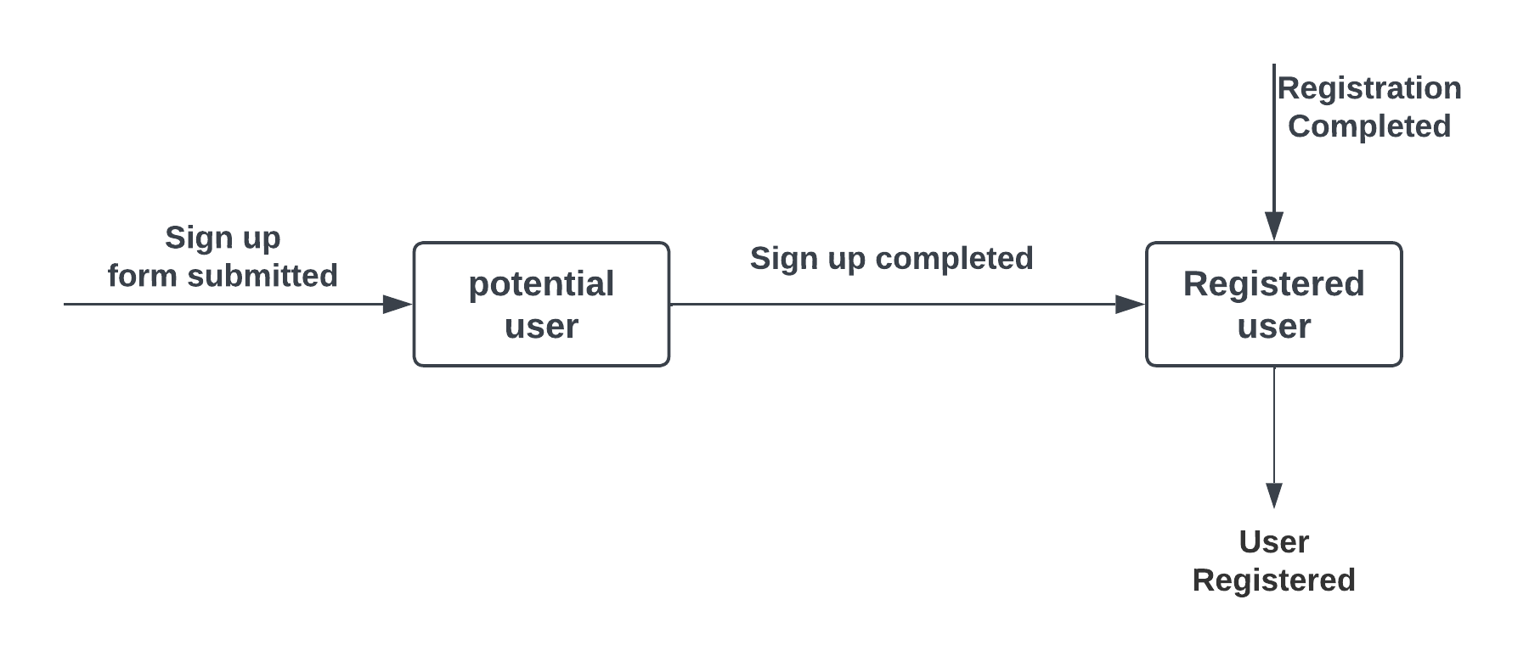

**Figure 25.1:** Statechart diagram (Potential user to Registered user)

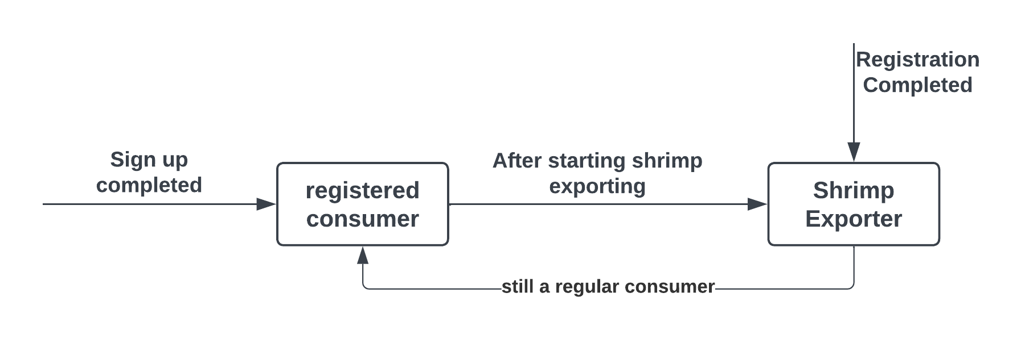

**Figure 25.2:** Statechart diagram (Registered Consumer to Shrimp Exporter)

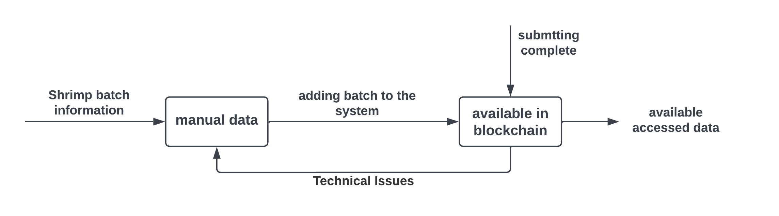

**Figure 25.3:** Statechart diagram (Manual Data to Automated Data)

## CRUD matrix

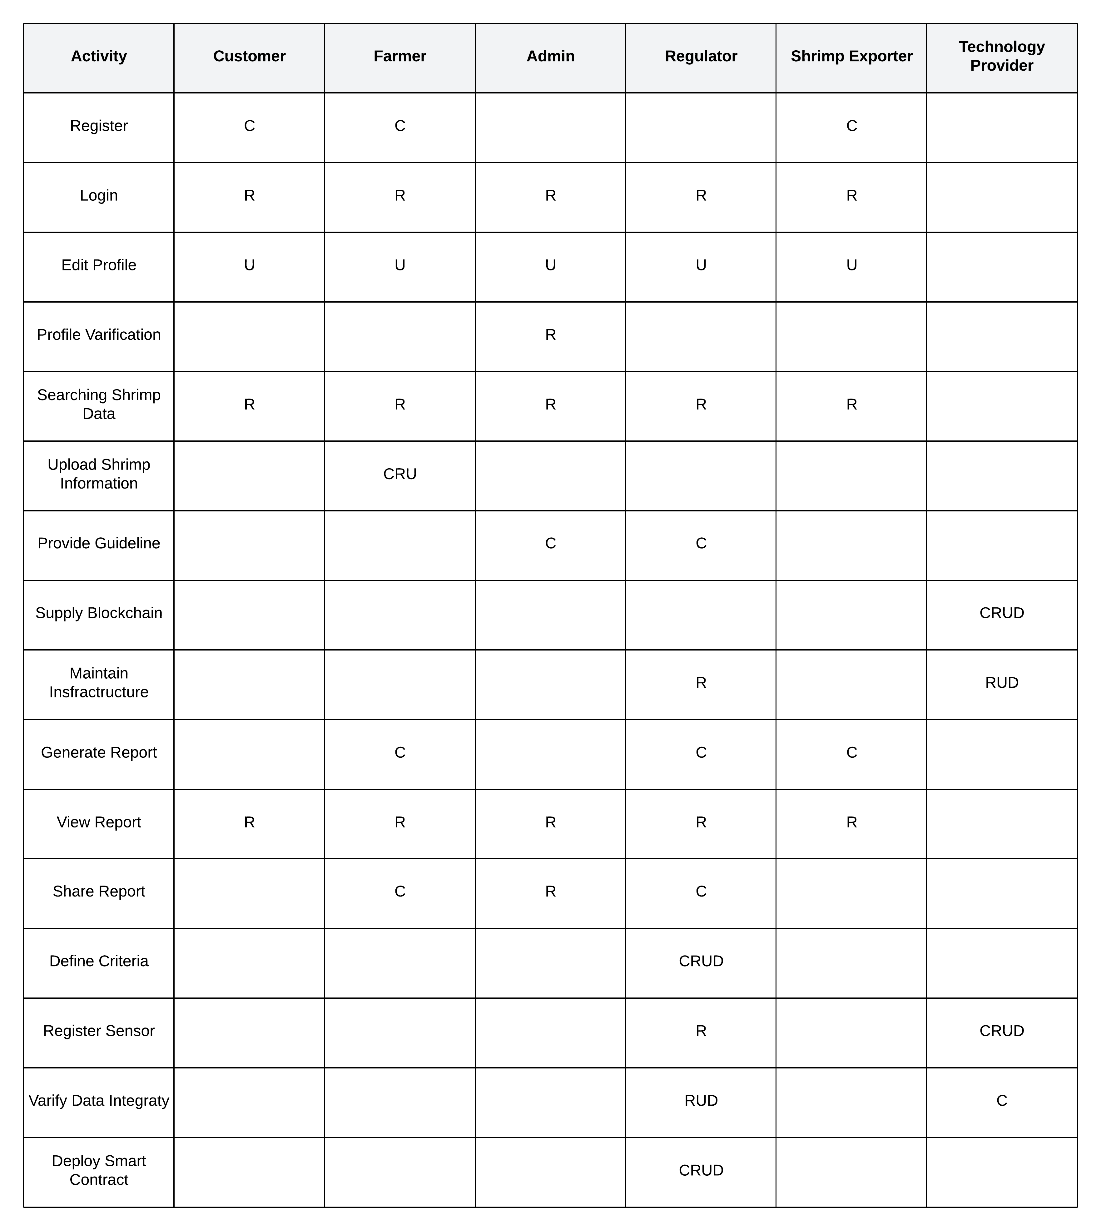

**Figure 26.1:** CRUD Matrix

# Section 6:

## Structure English pseudo code for the system

**User sign-Up:**

If "Sign Up" clicked Then

Get registration form

Username = input("Enter your username: ")

Password = input("Enter your password: ")

Email = input("Enter your email: ")

NID = input("Enter your NID number: ")

if User Exists In Database(username):

print("Username already taken")

else:

GET user input

New User = {

"username": username,

"password": Hashed Password,

"email": email

"NID": NID

}

Add User To Database(New User)

print("User successfully registered")

**Login by user:**

Get user inputs

Username = input("Enter your username: ")

Password = input("Enter your password: ")

User Data = Get User From Database(Username)

if User Data is not null and Password == User Data["password"]:

print("Login successful")

else:

print("Invalid username or password")

**Capture journey data by Farmer:**

If Farmer logs into the system

Username = input("Enter your username: ")

Password = input("Enter your password: ")

Farmer Data = Get Farmer From Database(Username)

if Farmer Data is not null and Password == Farmer Data["password"]:

print("Login successful")

// Capture journey data

Origin = input("Enter origin: ")

Harvest Date = input("Enter harvest date: ")

Processing Details = input("Enter processing details: ")

Temperature = input("Enter temperature: ")

Contamination = input("Is contamination detected? (yes/no): ")

// Create a journey data object

Journey Data = {

"origin": Origin,

"Harvest Date": Harvest Date,

"processing Details": Processing Details,

"temperature": Temperature,

"ph level": ph Level,

"oxygen level": Oxygen Level

"Carbon dioxide level": Carbon Dioxide Level

"Ammonia content": Ammonia Content

"color changes: Color Changes

"Texture changes": Texture Changes

"contamination": Contamination

}

// Store journey data in the database

Store Journey Data In Database(Farmer Data["id"], Journey Data)

print("Journey data captured and stored")

else:

print("Invalid username or password")

**Shrimp Quality Tracking by Consumer:**

User login into the system

If scanned QR code

Scanned QR Code = input("Scan the QR code: ")

Prawn Data = Get Prawn Data From Database(Scanned QR Code)

if Prawn Data is not null:

print("Prawn Quality Information:")

print("Origin:", Prawn Data["origin"])

print("Harvest Date:", Prawn Data["harvest Date"])

print("Processing Details:", Prawn Data["processing Details"])

if Prawn Data["Colour"] != Colour Array:

print("Colour change not acceptable! Quality compromised.")

if Prawn Data["contamination"] == "yes":

print("Contamination detected! Quality compromised.")

"ph level": ph Level,

"oxygen level": Oxygen Level

"Carbon dioxide level": Carbon Dioxide Level

"Ammonia content": Ammonia Content

"color changes: Color Changes

"Texture changes": Texture Changes

else:

print("Invalid QR code or prawn data not found")

**Monitor and verify quality data:**

If Regulator login into the system

Username = input("Enter your username: ")

Password = input("Enter your password: ")

Regulator Data = Get Regulator From Database(Username)

if Regulator Data is not null and Password == Regulator Data["password"]:

print("Login successful")

Quality Data = Get All Quality Data From Database()

print("Quality Data Monitoring:")

for data in Quality Data:

print("Batch:", data["batch"])

print("Origin:", data["origin"])

print("Harvest Date:", data["Harvest Date"])

print("Processing Details:", data["Processing Details"])

"ph level": ph Level,

"oxygen level": Oxygen Level

"Carbon dioxide level": Carbon Dioxide Level

"Ammonia content": Ammonia Content

"color changes: Color Changes

"Texture changes": Texture Changes

// Regulator can take necessary actions based on the data

else:

print("Invalid username or password")

**Regulator provide guidelines:**

//Provide Guidelines by Regulator

If Regulator login into the system

Username = input("Enter your username: ")

Password = input("Enter your password: ")

Regulator Data = Get Regulator From Database(Username)

if Regulator Data is not null and Password == Regulator Data["password"]:

print("Login successful")

// Retrieve farming guidelines from the database

Farming Guidelines = Get Farming Guidelines From Database()

print("Farming Guidelines:")

print(Farming Guidelines)

// Retrieve user guidelines from the database

User Guidelines = Get User Guidelines From Database()

print("User Guidelines:")

print(User Guidelines)

// Regulator can review and modify guidelines as needed

else:

print("Invalid username or password")

**Monitor Compliance:**

If Admin logs into the system

Username = input("Enter your username: ")

Password = input("Enter your password: ")

Admin Data = Get Admin From Database(Username)

if Admin Data is not null and Password == Admin Data["password"]:

print("Login successful")

// Retrieve compliance data for monitoring

Compliance Data = Get All Compliance Data From Database()

// Display compliance data to the admin

print("Compliance Monitoring:")

for data in Compliance Data:

print("Batch:", data["batch"])

print("Regulation:", data["regulation"])

print("Status:", data["status"])

// Additional compliance information can be displayed

// Admin can take necessary actions based on the compliance data

else:

print("Invalid username or password")

**System functionality check:**

If Technology provider logs into the system

Username = input("Enter your username: ")

Password = input("Enter your password: ")

Tech Provider Data = Get Tech Provider From Database(Username)

if Tech Provider Data is not null and Password == Tech Provider Data["password"]:

print("Login successful")

Audit Data = Get All Audit Data From Database()

// Display audit data to the technology provider

print("Audit Data Monitoring:")

for data in Audit Data:

print("Batch:", data["batch"])

print("Date:", data["Audit Date"])

print("Auditor:", data["auditor"])

print("Outcome:", data["outcome"])

// Check for data gaps

Missing Data Batches = Check For Data Gaps()

if is Empty(Missing Data Batches):

print("No data gaps detected")

else:

print("Data gaps detected for batches:", Missing Data Batches)

else:

print("Invalid username or password")

## Prototype the user interface

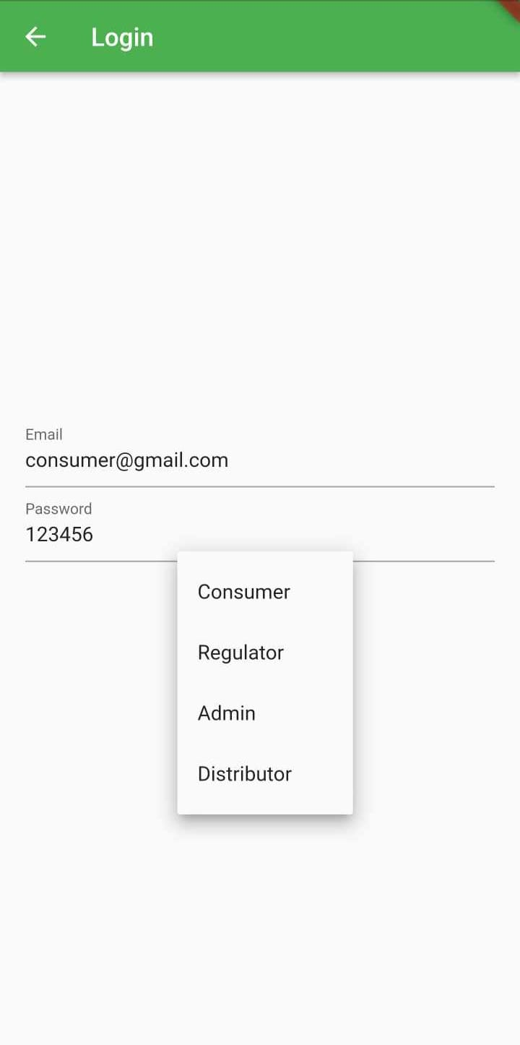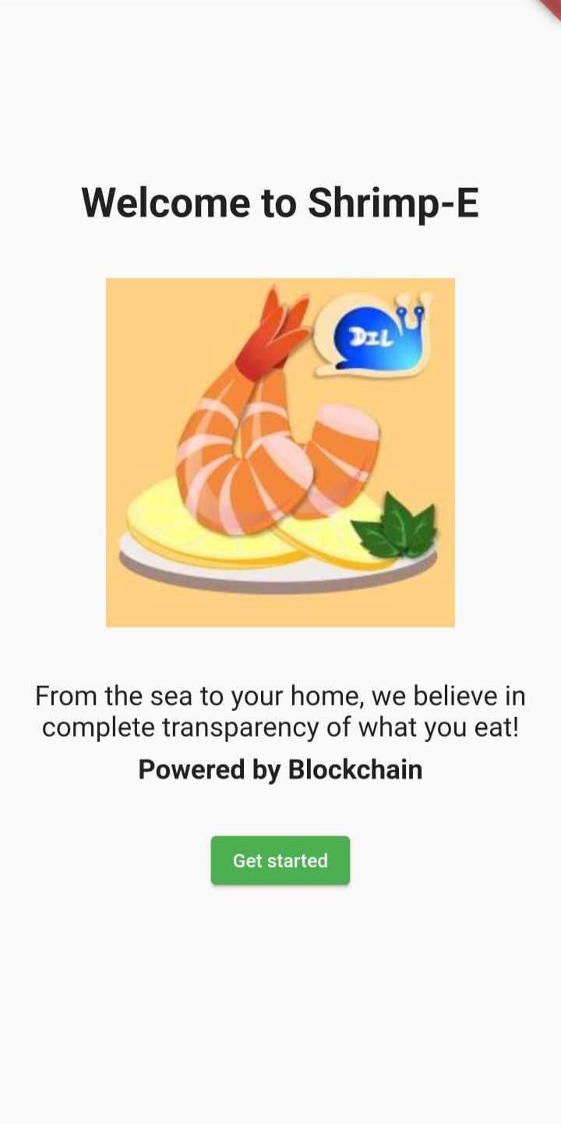

**Figure 28.2:** User Login

**Figure 28.1:** Homepage

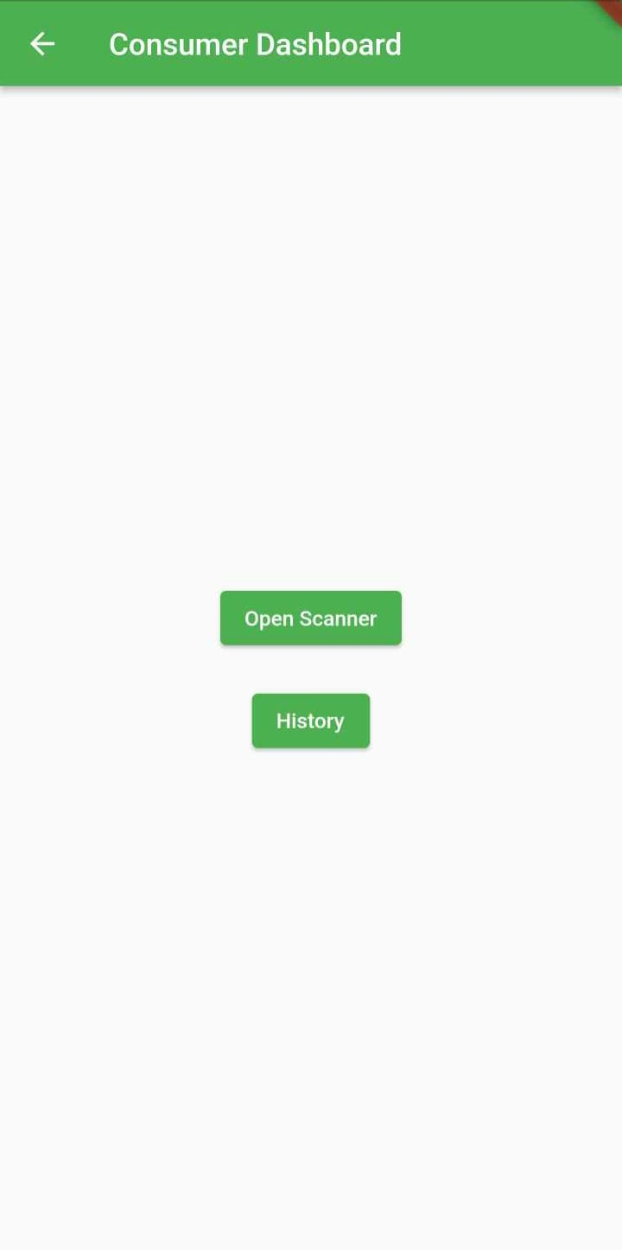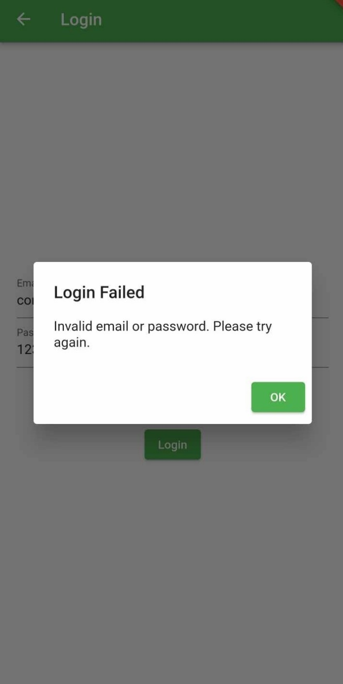

**Figure 28.2:** Consumer Dashboard

**Figure 28.2:** User Login (Failed for enter invalid information)

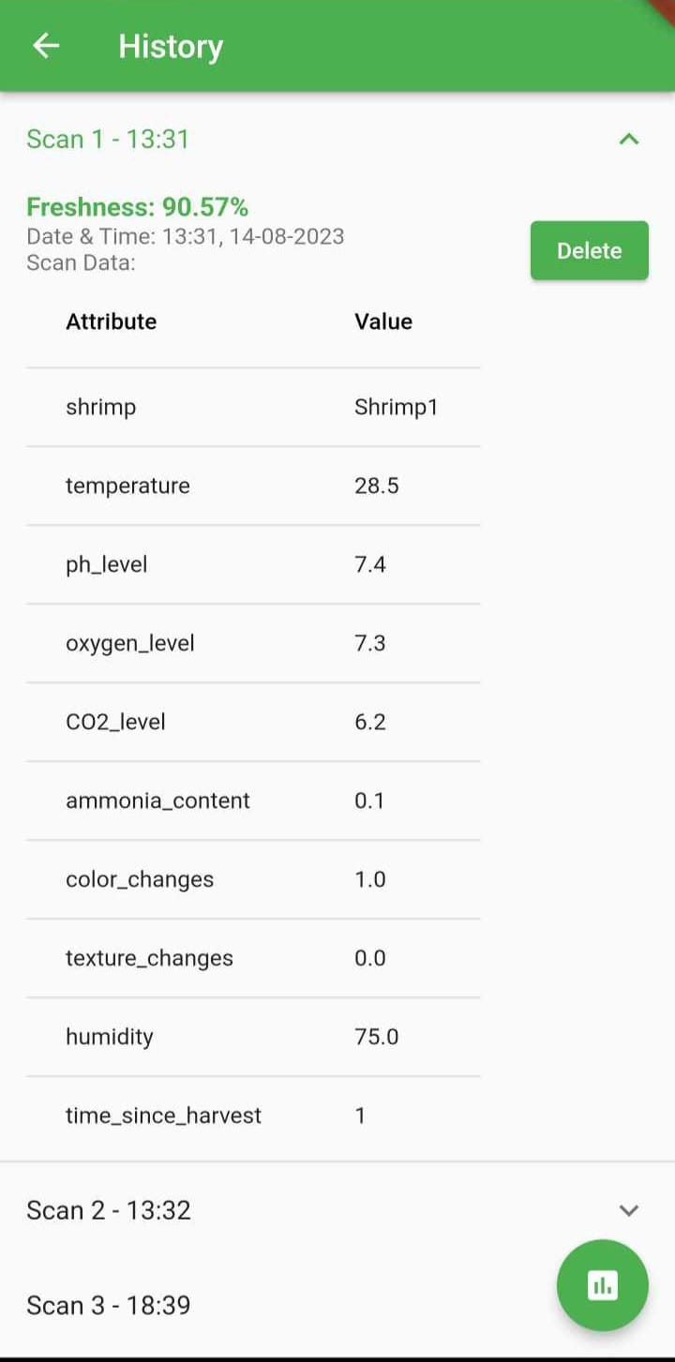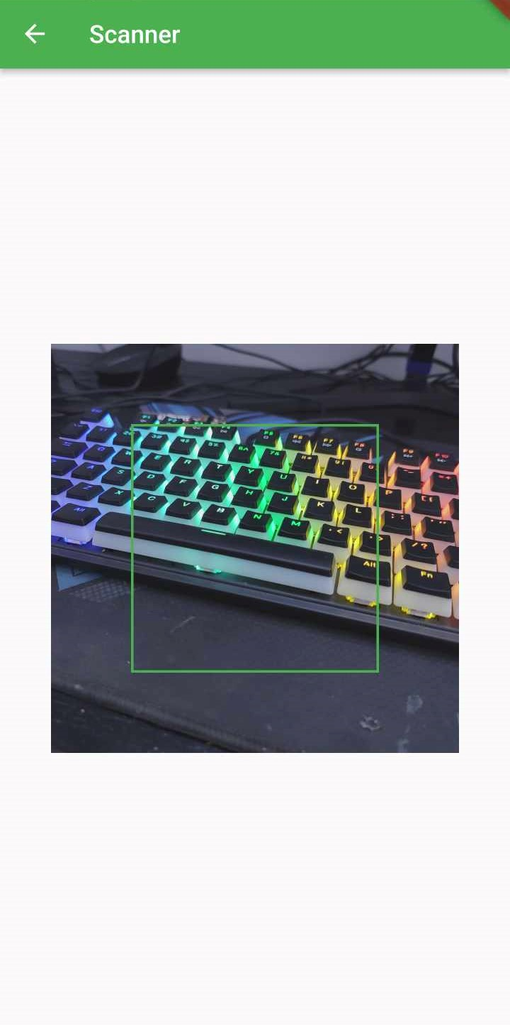

**Figure 28.2:** Using camera for scan QR code

**Figure 28.2:** Quality Data found by scanning QR code

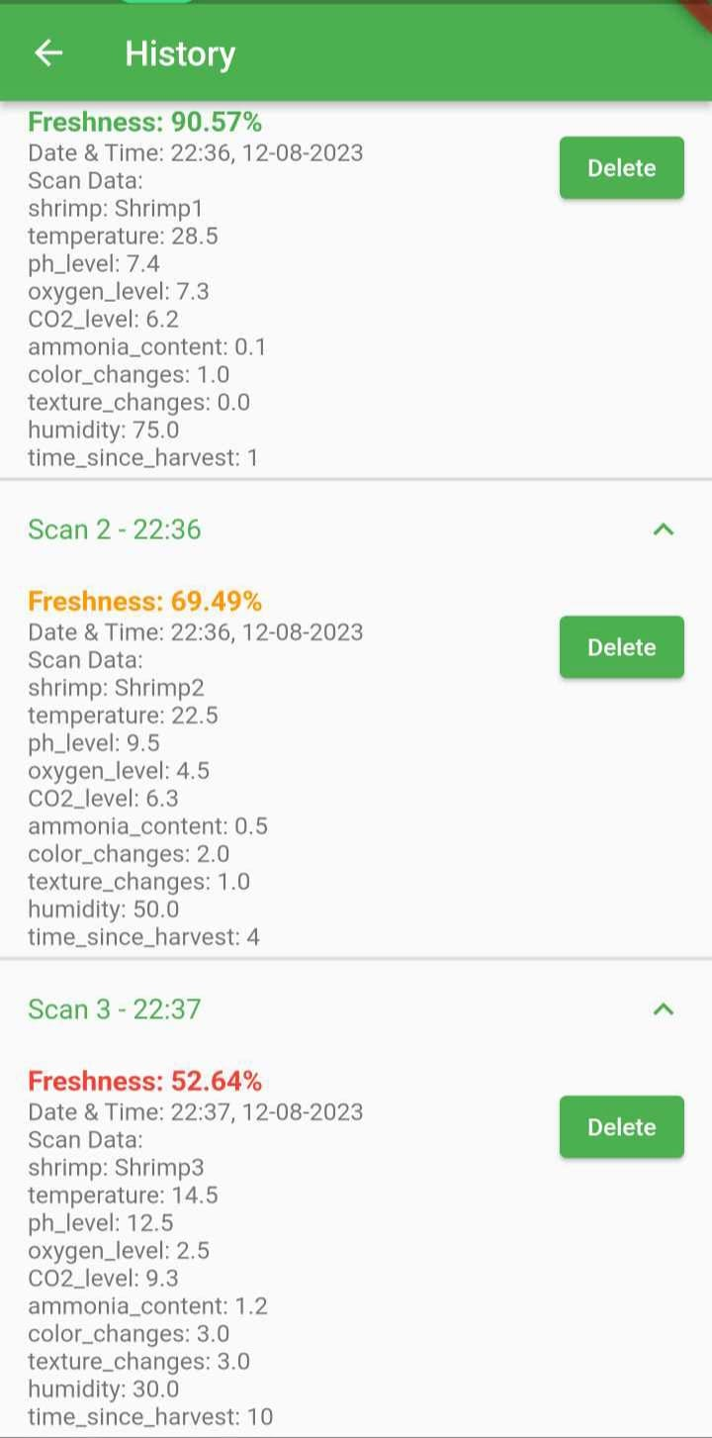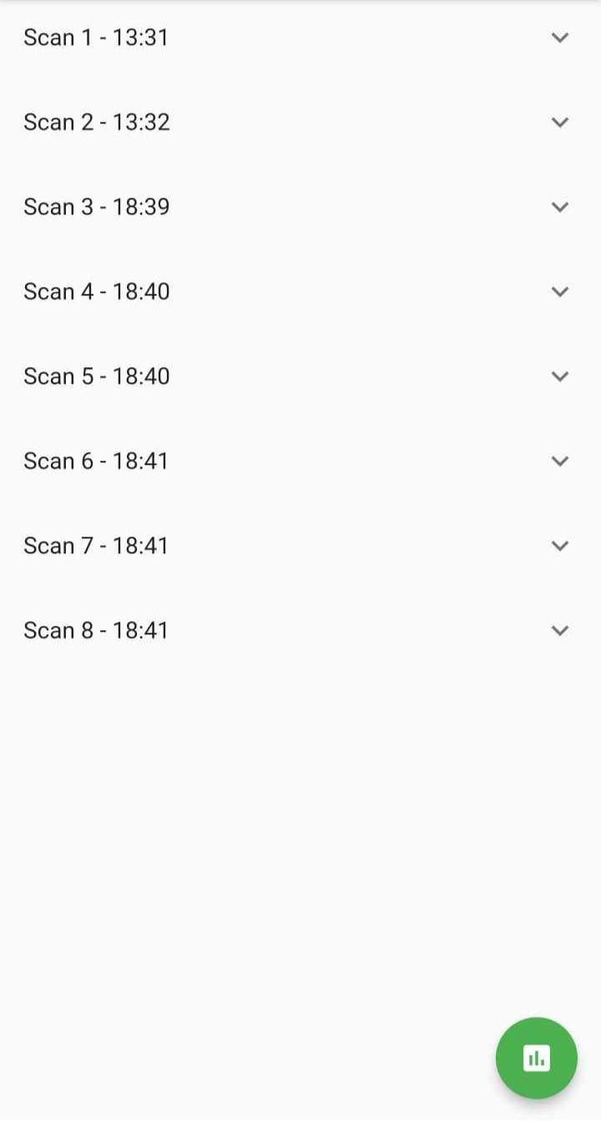

**Figure 28.2:** QR Code Scanned History data showing

**Figure 28.2:** QR Code Scanned History

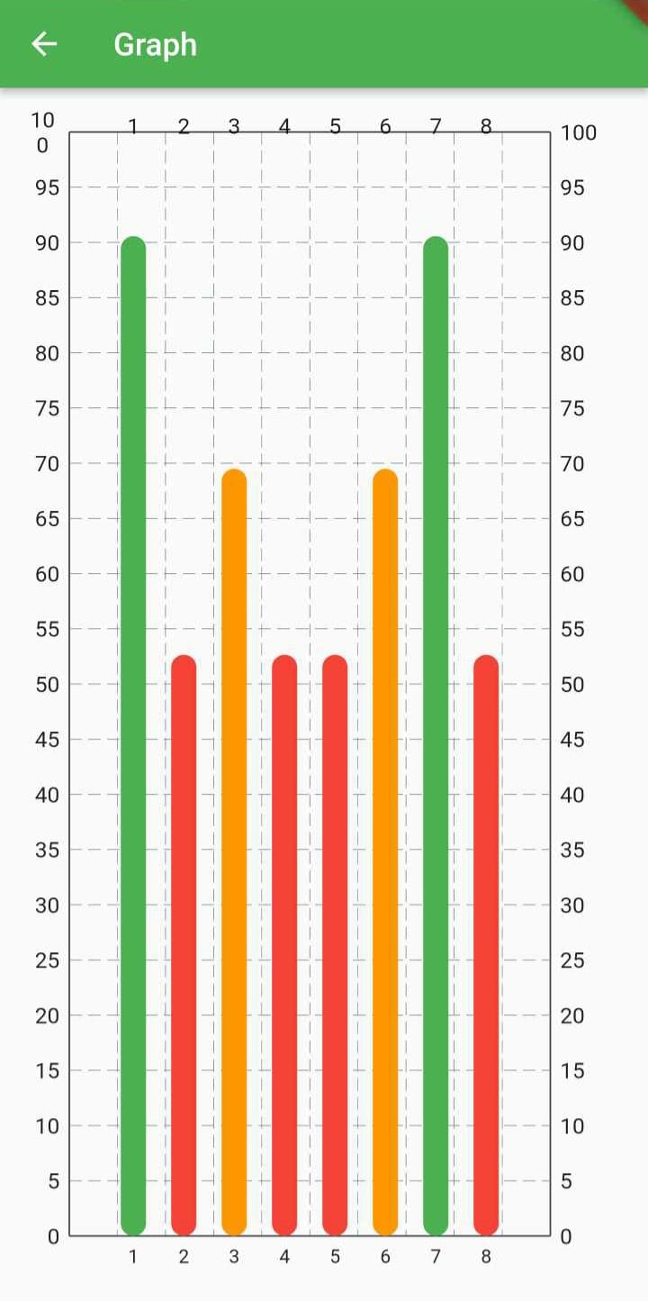

**Figure 28.2:** Visualize graph to showing percentage of freshness with color code